SENIOR FIVE TERM 2
TOPIC 2: Nutrition in Plants
Competency: The learner evaluates the nutritional strategies of carbon three (C3) and carbon four (C4) plants by analyzing their photosynthetic pathways and adaptation to environmental conditions so as to optimize agricultural productivity and food security under varying climatic conditions.
Contents
Autotrophic Nutrition 3
The parts of chloroplasts and their functions 4
Adaptations of the parts of the chloroplast to their function 4
General adaptations of chloroplasts to their functions 5
Similarities between a chloroplasts and a mitochondrion 5
Similarities between cellular respiration and photosynthesis 7
Differences between photosynthesis and Respiration 8
Chemistry of photosynthesis 8
Differences between cyclic and non-cyclic photophosphorylation 11
C3 and C4 plants 13
Advantages of C4 plants over C3 plants 13
Disadvantage of C4 plants over C3 plants 14
CAM Plant e.g. pineapple 15
Difference between C3, and C4 plant 15
Differences between C4 and CAM plants 15
Distribution of C4 and C3 plants 16
Photorespiration 17
Conditions necessary for photosynthesis 18
Limiting factors in respect to photosynthesis 20
Functions of tissues in dicotyledonous leaves 22
Adaptation of leaves to photosynthesis 22
Theories that explain the opening of stomata 22
Modification of leaves to their functions 24
Experiment to measure the rate of photosynthesis 25
Adaptations to photosynthesize in sun and shade 26
Importance of bacteria 27
The significance of chemosynthetic bacteria in an ecosystem 27
Effects of Light on organisms 27
Effects light on Plants 27
Effects light on Animals 28
Revision Exercise 29
Structured questions 40
Paper 2 revision questions 52

Autotrophic Nutrition
This is the synthesis of organic compounds from inorganic sources.
There are two types autotrophic nutrition.
- Chemosynthesis: is the synthesis of organic compounds from carbon dioxide and water using energy from oxidation of inorganic materials such as hydrogen sulphide, ammonia and iron II.
- Photosynthesis is the synthesis of organic compounds from carbon dioxide and water using energy from light.

Importance of Autotrophic nutrition
- Sugars resulting from autotrophic nutrition constitute structures of plants and animals
- Sugars obtained from autotrophic nutrition are source of energy
- Human depend on photosynthesis for energy containing fuel, which have developed over millions of years
- Photosynthesis maintains a constant concentration of carbon dioxide and oxygen in atmosphere. Oxygen is added to atmosphere as a result of photosynthesis while carbon dioxide is removed.

Photosynthesis
The main organelle for photosynthesis is the chloroplast

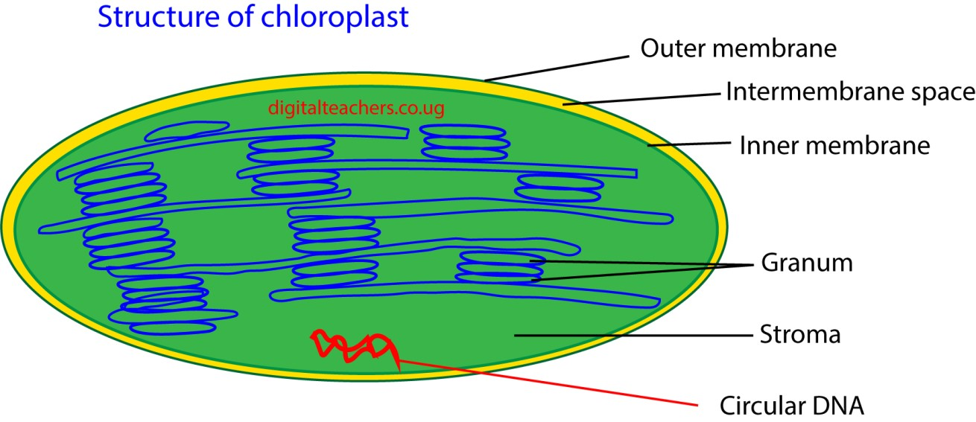

Chloroplast is biconcave (to increase the surface area for absorption of light) It is bound by a double membrane within which are numerous structures called thylakoids. Each thylakoid consists of a pair of membrane close to each other with narrow spaces between them. In places, the thylakoid is arranged in a neat stack, rather like a pile of coin called granum (pl.
grana). The grana are connected to each other by a less regular arrangement of the inter grana thylakoids. The thylakoid system is embedded in a protein rich matrix called stoma

The parts of chloroplasts and their functions
Outer membrane: acts as protective barrier and regulates the movement of molecules in and out of the chloroplast.
Inner membrane: encloses the stroma and is involved in the transport of materials Thylakoid membrane: Contains chlorophyll and is the site of light- dependent reactions of photosynthesis.
Stroma: The fluid-filled space where the Calvin Cycle ( Light independent reactions) occurs, synthesizing sugars.
Lamellae: Connects thylakoids and helps in organization of thylakoid membrane.
These components work together to facilitate photosynthesis and other metabolic processes in plant cells..

Adaptations of the parts of the chloroplast to their function
Thylakoids and grana: Thylakoids are flattened, disc-shaped sacs where the light-dependent reactions of photosynthesis occur.

Adaptations
- Thylakoids are arranged into stacks called grana (singular: granum). This stacking creates a large surface area for the membrane, which is crucial for embedding the maximum number of photosystems (light-harvesttrapping pigments) and ATP synthase enzymes.
- Tthylakoid membranes contain chlorophyll and other light-absorbing pigments organized into photosystems (PSII and PSI). This arrangement maximizes the absorption of light energy. The pigments are arranged in funnel-like structures to efficiently transfer light energy to the reaction center.
- The lumen (the space inside the thylakoid) has a very small volume. This allows a steep proton (H⁺) gradient to build up very quickly during chemiosmosis, powering ATP synthase to produce ATP.
Stroma: The stroma is the jelly-like fluid that fills the chloroplast and surrounds the thylakoids. It is where the light-independent reactions (Calvin cycle) occur.

Adaptations
- The stroma contains a high concentration of the enzymes needed to catalyze the Calvin cycle, including the enzyme RuBisCO.
- The stroma can store the products of photosynthesis as starch grains and lipid droplets for later use.
- The stroma bathe the grana, allowing the ATP and NADPH produced during the lightdependent reactions to rapidly diffuse to the sites of the Calvin cycle.
- The stroma contains small (70S) ribosomes and a circular loop of DNA (cpDNA), allowing it to synthesize some of its own proteins and enzymes without relying on the nucleus. Chloroplast envelope (double membrane)

Adaptations
- The outer and inner membranes enclose the chloroplast, separating its contents from the rest of the cell. This allows for specific conditions, such as a suitable pH and enzyme concentrations, to be maintained for photosynthesis.
- The inner membrane is less permeable than the outer and contains specific transport proteins. These proteins regulate the passage of molecules, like the G3P product of the Calvin cycle, into and out of the cytoplasm.

General adaptations of chloroplasts to their functions
- It is biconcave (to increase the surface area for absorption of light
- Outer membrane is semi- permeable to regulate entry and exit of substances for maintaining internal chloroplast environment.
- Contains chlorophyll to trap light for photosynthesis
- Abundant enzymes catalyse photosynthetic reactions in the stoma
- Grana provide large surface area for photosynthetic pigments, electron carriers and ATP synthase enzymes.
- Grana surrounded by the stroma so the products from the light dependent reaction (which occur across the thylakoid membrane which make up the grana) can readily pass into the stroma for the light independent reaction.
- Narrow inter-membrane space enables H⁺ ion concentration gradient to be rapidly established for chemiosmosis to occur
- Inner membrane contains molecules for electron transport pathway (ix) DNA presence codes for protein synthesis, including enzymes.
- Many ribosomes for protein synthesis to reduce on importing proteins from cytoplasm
- Outer membrane is permeable to gases like carbon dioxide which is a raw material for photosynthesis

Similarities between a chloroplasts and a mitochondrion
- Double membrane: Both organelles are enclosed by a double membrane, consisting of a smooth outer membrane and a highly specialized inner membrane.
- Internal compartments: The double membrane creates distinct internal compartments. In mitochondria, it is the inner mitochondrial matrix and the intermembrane space. In chloroplasts, it is the stroma, thylakoid lumen, and intermembrane space.
- Increased surface area: Both have internal membrane systems with a large surface area. In mitochondria, the inner membrane folds into structures called cristae. In chloroplasts, the inner membrane encloses flattened sacs called thylakoids, which stack into grana. This increased surface area is vital for embedding the enzymes and protein complexes needed for their metabolic reactions.
- Circular DNA: Both contain their own small, circular DNA molecule, much like that found in bacteria. This DNA codes for some of the organelle's proteins.
- Ribosomes: Both possess their own ribosomes, which are similar in size and structure to bacterial ribosomes (70S). This allows them to synthesize some of their own proteins.
- Replication by fission: Both organelles can replicate independently of the cell nucleus through a process similar to prokaryotic binary fission.
Functional similarities
- ATP production: A central function for both is the synthesis of ATP, the main energy currency of the cell. They both utilize an electron transport chain to generate a proton (H⁺) gradient, which is then used by the enzyme ATP synthase to produce ATP through chemiosmosis.
- Energy conversion: Both are specialized for energy transformation. Chloroplasts convert light energy into chemical energy stored in glucose, and mitochondria convert the chemical energy stored in glucose into usable ATP.
- Enzymatic activity: Both contain a complex system of enzymes and coenzymes to catalyze their specific biochemical pathways.
- Evolutionary similarities (Endosymbiotic Theory): The striking similarities between mitochondria, chloroplasts, and bacteria provide strong evidence for the endosymbiotic theory. This theory proposes that both organelles originated from free-living prokaryotic cells that were engulfed by a larger host cell. Mitochondria are thought to have evolved from aerobic bacteria (alpha-proteobacteria)while Chloroplasts are believed to have evolved from photosynthetic cyanobacteria. This shared history explains why they retained their own genetic material, ribosomes, and ability to divide, characteristics not typically found in other eukaryotic organelles.

Differences between a chloroplasts and a mitochondrion
Mitochondria | Chloroplast
Known as the powerhouse of the cell, it is responsible for energy metabolism and cellular respiration | Larger and much more complex than a mitochondrion, it is the site where photosynthesis takes place.
Present in cells of all types of aerobic organisms such as plants and animals. | Present in green plants and green algae
Bean-shaped | Disc-shaped
Colourless organelle | Green in colour
Matrix and Cristae are the two chambers present in a mitochondrion | Stroma and thylakoid are the two chambers of a chloroplast
Consumes oxygen | Releases oxygen
Produce carbon dioxide | Produce carbon dioxide
Do not possess any pigments | Chloroplast is comprised of pigments such as chlorophyll, carotenoids and photosynthetic pigments
Energy is released by breaking down organic food producing carbon dioxide and water | Stores energy and uses carbon dioxide and water to produce glucose

Similarities between cellular respiration and photosynthesis
- Energy Conversion: Both processes convert energy from one form to another— photosynthesis turns light energy into chemical energy (glucose), while respiration converts chemical energy into usable energy (ATP).
- Electron Transport Chains: Each process uses an electron transport chain to move electrons and generate energy-rich molecules (ATP, NADPH in photosynthesis; ATP, NADH, FADH₂ in respiration).
- Enzyme Involvement: Enzymes catalyze the reactions in both processes, ensuring efficient energy transformation and molecular changes.
- ATP usage and production: ATP is central to both processes—photosynthesis produces ATP during the light-dependent reactions, and respiration uses and generates ATP during glycolysis and oxidative phosphorylation.
- Redox Reactions: Both involve oxidation-reduction (redox) reactions, where electrons are transferred between molecules to facilitate energy flow.
- Organelles: Photosynthesis occurs in chloroplasts, while respiration takes place in mitochondria—both specialized organelles in eukaryotic cells.
- Biochemical Pathways: Both processes consist of a series of biochemical reactions that are enzyme controlled.
- Carbon-Based Compounds: Both processes involve carbon compounds—photosynthesis uses carbon dioxide to make glucose, and respiration breaks down glucose to release carbon dioxide.
- Interdependence: The products of one process serve as the reactants for the other. Photosynthesis produces glucose and oxygen, which are used in respiration; respiration produces carbon dioxide and water, which are used in photosynthesis.

Differences between photosynthesis and Respiration

Photosynthesis Respiration
- Converts light energy into chemical Releases energy from glucose for cellular energy (glucose use
- Occur in chloroplasts Occur in mitochondria
- Use carbon dioxide Use oxygen
- Produce glucose Breakdown glucose
- Require energy (light) Produce energy (ATP)
- Electron carrier NADPH Electron carriers are NADH and FAD
- Anabolic (builds molecules). Catabolic (breaks down molecules).
- Absorb carbon dioxide Release Oxygen
- Produce oxygen Produce carbon dioxide
- Use water Produce water

Chemistry of photosynthesis
In the process of photosynthesis energy is obtained from sunlight is trapped by chlorophyll and used for the manufacture of carbohydrates from carbon dioxide and water. The process is summarized by the following equation

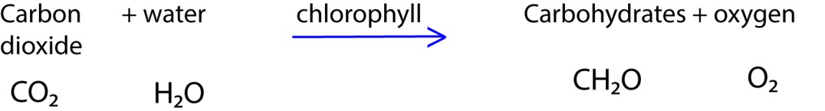

Photosynthesis takes place in 3 stages
- Light harvesting
- Electron transport
- Reduction of carbon dioxide

1. Stage 1: Light harvesting
Pigment molecules in thylakoid membrane absorb and collect solar energy and funnel it to special molecules of chlorophyll a known as the reaction centre chlorophyll molecule. When light energy strikes this molecule, an electron is excited and picked by electron acceptor.

There are two kinds of reaction centres in plants called photosystem I (PSI) and photosystem II (PS II) that differ in structure and function. PSI absorbs light at 700nm and PSII at 690nm. Whereas many chlorophyll molecules are involved in collecting energy, only a few make up the reaction centres.

The transport of electrons through the two centres comprises the second state of photosynthesis.

2. Stage 2: electron transport

This stage occurs in thylakoid of the chloroplast and produces ATP and reduced nicotinamide adenine phosphate, (NADPH) to be used in the reduction of carbon dioxide in the third stage.

The events of electron transport are described in the figure below

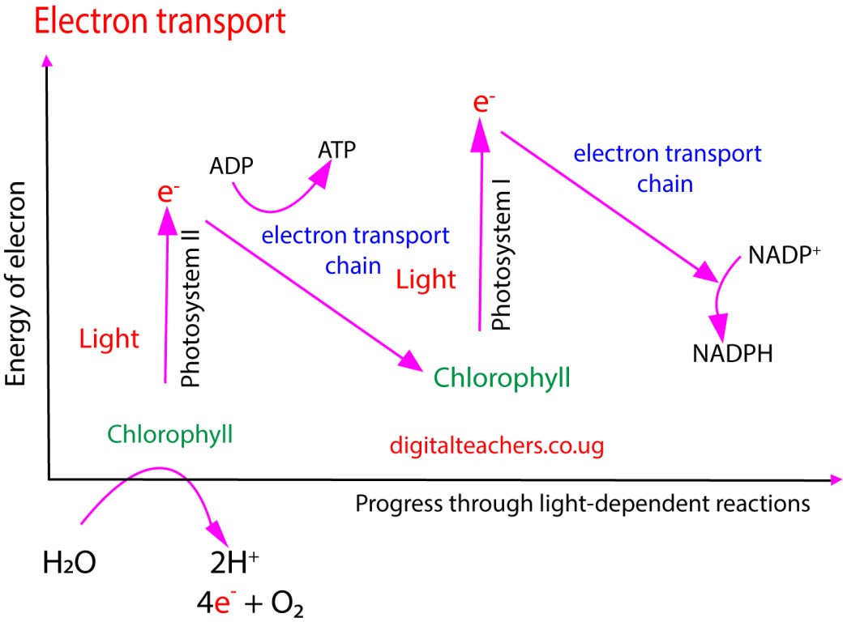

(i) Formation of NADPH
When light is absorbed by a chlorophyll molecule PSI an electron is displaced and transferred to an electron acceptor which donates it to a protein ferredoxin. Ferredoxin then passes the electron to NADP which is reduced to NADPH.

The electron lost by PSI is restored from PSII. When PSII absorbs light energy, an electron is displaced from it and passes through electron carrier system which includes cytochromes.

The electron lost from PSII is then restored through photolytic splitting of water (Hill reaction)

(ii) ATP formation
- Non cyclic photophosphorylation
The flow of electrons from PSII to PSI in thylakoid membrane causes accumulation of H⁺ inside the thylakoid space creating a gradient. The passage of H⁺ out of the thylakoid provides energy to synthesize ATP.

- Cyclic photophosphorylation
Here when PSI is struck by light, electron is excited, passes through electron carrier system and then returned to PSI; that is PSI is the electron donor and acceptor. H⁺ builds up in the thylakoid space creating a gradient. Then the passage of H⁺ out of the thylakoid provides energy for synthesizing ATP. It is used to synthesize ATP when synthesis of NADPH₂ is not necessary.

Differences between cyclic and non-cyclic photophosphorylation
 | Cyclic photophosphorylation | Non-cyclic photophosphorylation
1 | It occurs only in PS I | It occurs only in PS I and PS II
2 | It involves synthesis of ATP | It involves synthesis of ATP and NADPH₂
3 | Photolysis of water does not occur | Photolysis occurs and oxygen is liberated
4 | Electron motion is cyclic | Electron motion is non-cyclic

3. Reduction of carbon dioxide
This involves a cyclic chain reaction called Calvin cycle. It occurs in the stroma of chloroplast where NADPH and ATP from stage 2 provide reducing power and energy for synthesis of sugars.

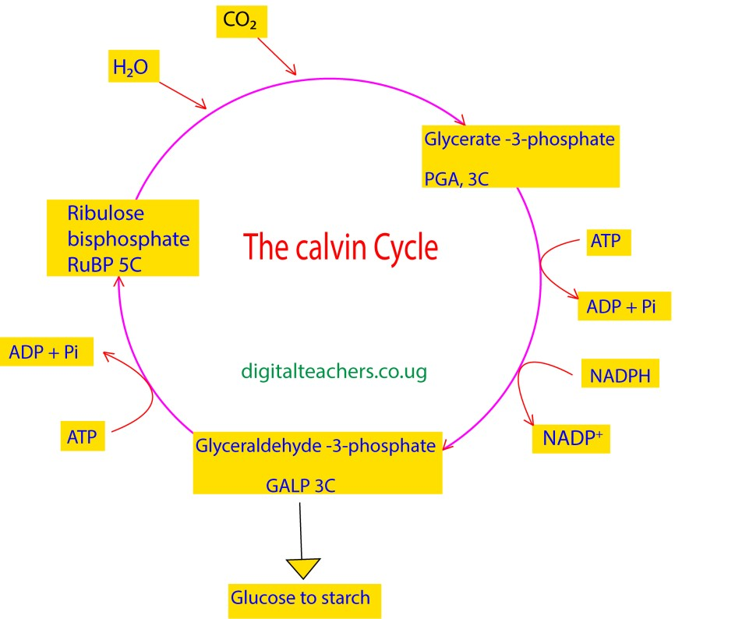

- In the first step, carbon dioxide combines with a 5-carbon organics compound called ribulose bisphosphate (RUBP) with the aid of an enzyme ribulose bisphosphate carboxylase giving unstable 6-carbon compound.
- The unstable 6-carbon compound immediately splits into two molecules of 3-carbon compound glycerate-3-phosphate, (GP)
- The GP is reduced to form a 3-carbon sugar, glyceraldehyde-3-phosphate (GALP). The hydrogen for reduction comes from NADPH which also supplies most of the energy, the rest coming from ATP.

- The 3-carbon sugar is built into a 6-carbon sugar which may be converted into starch for storage.

- Some of the 3-carbon sugar is used to regenerate ribulose bisphosphate to be used in the Calvin cycle.

Synthesis of proteins using photosynthesis intermediates (ATP, NADPH, G3P)
- Photosynthesis doesn't produce proteins directly; instead, it provides the essential carbon skeletons (via G3P) and energy (ATP and NADPH) required for other metabolic pathways to synthesize amino acids.
- Glyceraldehyde-3-phosphate (G3P) is converted into several carbon skeletons for the various amino acids through a series of reactions.
- Nitrogen (Nitrates) from the soil is combined with the carbon skeletons to form amino acids.
- Amino acids are assembled into proteins through a process of translationpowered by ATP

The synthesis of lipids using photosynthesis intermediates (ATP, NADPH, G3P)
This transformation lipid from G3P is not a single reaction but a multi-step metabolic pathway that takes place in different cellular compartments, notably the chloroplast and endoplasmic reticulum.
- G3P produced in the Calvin cycle with the chloroplast is exported to the cytoplasm, processed through parts of glycolysis pathways to pyruvate.
- The pyruvate is then transported into the plastids, where it is converted into acetyl-CoA, the two-carbon building block for fatty acids. This process is called pyruvate dehydrogenase.
- The synthesis of fatty acids occurs within the plastids and is a cyclic process catalyzed by the fatty acid synthase (FAS) enzyme complex. This process requires significant amounts of energy (ATP) and reducing power (NADPH) provided by photosynthesis.
- The FAS complex repeatedly adds two-carbon units (from malonyl-CoA, which is derived from acetyl-CoA) to a growing fatty acid chain. This continues until major fatty acids, such as palmitic acid (C16:0) and oleic acid (C18:1), are formed.
- The newly synthesized fatty acids are exported from the plastids to the cytoplasm.
- G3P from the cytoplasm is converted into glycerol-3-phosphate, forming the backbone for glycerolipids.
- The endoplasmic reticulum, the fatty acids are attached to the glycerol-3-phosphate backbone in a series of steps known as the Kennedy pathway.
- Glycerol-3-phosphate acyltransferase (GPAT) adds the first fatty acid to G3P, forming lysophosphatidic acid (LPA).
- Lysophosphatidic acid acyltransferase (LPAAT) adds the second fatty acid, resulting in phosphatidic acid (PA).
- Diacylglycerol acyltransferase (DGAT) adds the third fatty acid, leading to the final storage lipid, triacylglycerol (TAG).

C3 and C4 plants
In C3 plant such as tomato, and rice, carbon dioxide is fixed by ribulose bisphosphate and the first stable intermediate in production of sugar is a 3-carbon compound, glycerate-3phosphate. However, the C4 plants such as sugar cane and maize fix carbon dioxide using phosphorenol pyruvic acid (PEP) and the immediate products of CO₂ fixation is a 4-carbon compound oxaloacetic acid.

The oxaloacetic acid formed in C4 plants is subsequently converted into maleic acid from which CO₂ is fed into the Calvin cycle to form carbohydrates.

Advantages of C4 plants over C3 plants
C4 plants have a significant advantage over C3 plants in hot, dry, and high-light environments due to their specialized anatomy and photosynthetic pathway. This adaptation minimizes the wasteful process of photorespiration and improves water and nitrogen use efficiency.
- C4 plants have reduced carbon dioxide wastage through photorespiration than in C3 plants: In C3 plants, the enzyme RuBisCO can bind with oxygen instead of carbon dioxide, especially under high temperatures and low 𝐶𝑂₂ conditions. This process, called photorespiration, wastes energy and reduces photosynthetic production. In contrast C4 plants use a special enzyme called PEP carboxylase, which has a higher affinity for 𝐶𝑂₂ than RuBisCO. They fix carbon dioxide in their mesophyll cells and transport it to specialized bundle sheath cells, where it is released at a high concentration to RuBisCO. This spatially separates the initial 𝐶𝑂₂ fixation from the Calvin cycle, effectively suppressing photorespiration.
- C4 plants conserve water more efficiently than C3 plants: In hot, dry conditions, C3 plants must keep their stomata open for longer periods to take in enough 𝐶𝑂₂ which also leads to significant water loss through transpiration. Whereas C4 plants can operate with their stomata partially or fully closed for longer periods. Their efficient carbonconcentrating mechanism allows them to continue photosynthesis effectively even at low internal 𝐶𝑂₂ levels, dramatically reducing water loss.
- C4 plants perform better at higher temperature and light than C3 plants: In full sunlight, C3 plants reach their maximum photosynthetic rate, or light saturation, well below the available light levels. C4 plants, in contrast, have a very high light saturation point. The energy-intensive C4 pathway works well with abundant sunlight, and their photosynthetic rate continues to increase with higher light intensity.
- C4 plants tolerate higher temperatures better than C3 plants: The C4 pathway gives plants a higher optimal temperature for photosynthesis. This is a major advantage in tropical and subtropical regions where high temperatures would increase photorespiration in C3 plants.
- C4 plants use nitrogen more efficiently than C3plants: Because C4 plants operate at high internal 𝐶𝑂₂ concentrations, they can function with much lower levels of RuBisCO. This is significant because RuBisCO is a very nitrogen-rich protein.By reducing the amount of nitrogen invested in RuBisCO, C4 plants can reallocate nitrogen to other metabolic processes or produce more biomass, especially in nitrogen-poor soils.

Disadvantage of C4 plants over C3 plants
While C4 plants are highly adapted for hot, dry, and high-light conditions, they have distinct disadvantages when compared to C3 plants in other environments
.
- C4 plants use more energy than C3 plants: The C4 pathway requires extra energy in the form of ATP to function. Specifically, it costs an additional two ATP molecules for every molecule of 𝐶𝑂₂ that is fixed compared to the C3 pathway. This extra energy is used to regenerate the 𝐶𝑂₂ carrier molecule, PEP (phosphoenolpyruvate), after it releases 𝐶𝑂₂ to the Calvin cycle in the bundle sheath cells.
- C4 have reduced efficiency in moderate climates: In cooler, temperate, or high-𝐶𝑂₂ conditions, C4 plants are less energy-efficient than C3 plants. Since photorespiration is naturally suppressed under these conditions, the extra ATP cost of the C4 pathway becomes an unnecessary metabolic burden that reduces overall photosynthetic efficiency.
- C4 plants perform poorly in low temperatures and light than C3 plant: The CO₂ fixing enzymes in C4 plants are less active at cool, moist and low illumination conditions, therefore photosynthesis occurs slowly at high altitude with cool temperature and in low light intensity of temperate conditions.
- Anatomical limitations: C4 plants require a specialized leaf anatomy (Kranz anatomy) with distinct mesophyll and bundle sheath cells to facilitate the spatial separation of the initial carbon fixation and the Calvin cycle. This more complex anatomy is an evolutionary constraint that limits the range of habitats they can occupy compared to the more widespread and diverse C3 plants

NB: C4 plants grow better under hot, dry conditions when plants must close their stomata to conserve water – with stomata closed, CO₂ levels in the interior of the leaf fall, and O₂ levels rise.

CAM Plant e.g. pineapple
These are C4 plants that live especially in arid environment. Because they are at risk of severe water loss, they have accustomed by opening their stomata at night. Thus as opposed to other C4 plants, in CAM plants, the initial fixation of CO₂ by PEP and the conventional Calvin cycle are separated in time. The stomata are generally closed during the day so there is little loss of water; the CO₂ is fixed during the night when the stomata are open.

Difference between C3, and C4 plant
 | C3 pathway | C4 pathway
1 | Photosynthesis occurs in mesophyll cells | Photosynthesis occurs in mesophyll cells and bundle sheath cells
2 | The CO₂ molecule acceptor is RuBP | The CO₂ acceptor molecule is phosphenol pyruvate
3 | The first stable product is a 3C compound Called Glycerate-3phosphate (PGA) | The first stable product is a 4C compound oxaloacetic acid (OAA)
4 | Photorespiration rate is high and leads to loss of fixed CO₂. Decrease CO₂ fixation rate | Photorespiration is negligible and is almost absent. Hence high CO₂ fixation rate
5 | Optimum temperature is 20⁰C to 25⁰C | Optimum temperature is 30 to 45⁰C.
6 | Photosynthetic rate is low | Photosynthetic rate is high
7. | Examples of C3 plants are rice, wheat and tomato | Examples of C4 plants are maize, sugar cane

Differences between C4 and CAM plants
C4 | CAM plant
Open stomata during day and close them at night | Open stomata at night and close them during day
Do not store CO₂ (carbon dioxide fixation and Calvin cycle is separated by space) | Store CO₂ in form of malate (carbon dioxide fixation and Calvin cycle is separated by time)

Distribution of C4 and C3 plants
The distribution of C3 and C4 plants is primarily driven by their contrasting physiological adaptations to environmental conditions, particularly temperature, water availability, and light intensity. C3 plants dominate cooler, wetter regions, while C4 plants are most successful in hotter, drier, and sunnier climates.

C3 plant distribution
As the most common photosynthetic type, C3 plants are found across nearly all terrestrial environments but dominate in specific climates.
• Cooler, temperate, and boreal regions: Because C3 plants are not disadvantaged by photorespiration in these conditions, they are more energy-efficient and competitive than C4 plants. They are the main component of temperate forests, boreal forests, and tundra

ecosystems.
- Higher latitudes and elevations: As temperature decreases with latitude and altitude, the C3 pathway becomes more favorable. Studies show a clear transition from C4-dominated to C3-dominated vegetation with increasing elevation on mountains.
- Shaded environments: In the understory of forests and other low-light environments, the C3 pathway's efficiency at low light intensity gives it a competitive edge.
- Major C3 crops: These include wheat, rice, soybeans, and potatoes, which are widely cultivated in temperate and wetter regions.

C4 plant distribution
C4 plants thrive in environments that challenge C3 plants. While a smaller fraction of all plant species, they account for a disproportionately large percentage of global primary production due to their dominance in grasslands and savannas.
- Hot, dry climates: C4 plants are most common in tropical and subtropical regions, including grasslands, savannas, and deserts, where their adaptations to high temperatures and water stress are most beneficial.
- High light intensity: In full sunlight, the C4 pathway does not reach saturation as quickly as the C3 pathway, allowing for higher productivity.
- Warm-season grasses: C4 grasses are often called "warm-season" grasses because they are most active during the warmer months. This leads to temporal separation from C3 grasses in mixed grasslands.
- High-salinity environments: The higher water-use efficiency of C4 plants also makes them successful in arid and saline environments, such as salt marshes.
- Major C4 crops: Important C4 crops like maize, sugarcane, and sorghum are cultivated extensively in tropical and subtropical regions, as well as warmer temperate zones like the "corn belt" of the central United States.

Factors influencing distribution
The primary climatic factor determining the boundary between C3 and C4 dominance is the growing season temperature.
- The "crossover temperature" is the point at which the photosynthetic efficiency of C3 and C4 plants becomes equal. Below this temperature, C3 plants have an advantage; above it, C4 plants are more productive.
- Water availability also plays a major role, especially in warmer regions, as C4 plants' superior water-use efficiency allows them to flourish in drier conditions where C3 plants would struggle.
- Atmospheric 𝐶𝑂₂ levels can also affect competition. C3 plants may respond more favorably to elevated𝐶𝑂₂, but in hot environments, the temperature effect can still give C4 plants an edge.

Definition
Photorespiration (also known as the oxidative photosynthetic carbon cycle, or CO₂ photosynthesis) refers to a process in plant metabolis where the enzyme RuBisCO oxygenates RuBP, causing some of the energy produced by photosynthesis to be wasted. This process reduces the efficiency of photosynthesis, potentially reducing photosynthetic output by 25% in C3 plants.
Differences between photorespiration and cellular respiration
Photorespiration | Cellular respiration
Energy is wasted | Energy is formed
substrate is glycolate | Substrate is glucose
Light dependent | Light independent
No photophosphorylation occurs | Photophosphorylation occurs
Requires mitochondria, peroxime, and chloroplast | Requires mitochondria only
Common in C3 plants | Occur in all plants

Conditions necessary for photosynthesis
- Carbon dioxide: is obtained from the atmosphere and water in case of aquatic plants. It is the source of carbon in carbohydrates.

Experiment to show that carbon dioxide is necessary for photosynthesis

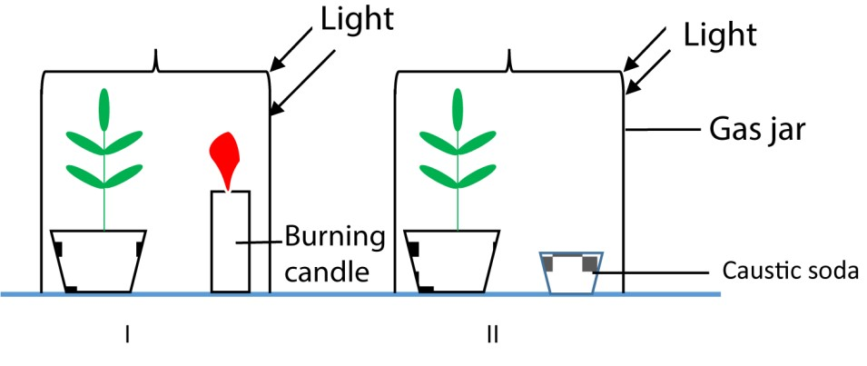
The experiment is set up as shown above
  - Two younger seedling growing in pots are kept in the dark for 3 days (to remove starch) and a leaf from each plant is tested to confirm absence of starch.
  - In experiment I the burning candle supplies carbon dioxide while in experiment II carbon dioxide is absorbed by caustic soda.

  - After 3 hours, a leaf is take from each plant and tested for the presence of starch. Starch is found in the leaf of experiment I which had carbon dioxide.

- Water provides hydrogen for the carbohydrates

- Light usually from the sun is the source of energy for photosynthesising tissues.

Wave length of light for photosynthesis
An action spectrum is the rate of a physiological activity plotted against wavelength of light. It shows which wavelength of light is most effectively used in a specific chemical reaction. Some reactants are able to use specific wavelengths of light more effectively to complete their reactions.

The action spectrum of chlorophyll is shown in the graph below

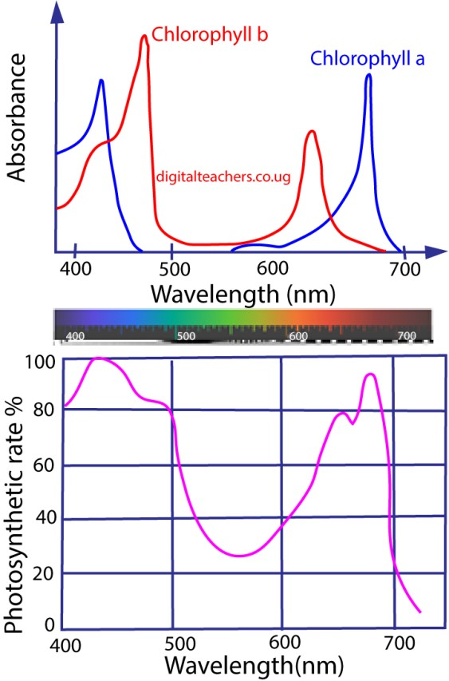

From the graph of action spectrum of chlorophyll, it observed that chlorophyll is much more efficient at using blue-violet light (wave length (550-400nm) and orange (600700nm).

However, Bacteriochlorophyll of purple sulphur bacteria absorb ultraviolet (350nm) and infrared (750nm) part of the spectrum. The difference in wavelengths optimum for photosynthesis both in plants and bacteria enables bacteria to survive under water weeds in the pond. I.e. bacteria find the spectrum useful after the plants have filtered out light for photosynthesis.

(d) Chlorophyll: this is a green pigment which helps to trap light energy for photosynthesis.

Experiment to show that chlorophyll is necessary for photosynthesis
When a variegated leaf is picked from a plant on a sunny day and tested for starch. Starch is found only in parts that originally contained chlorophyll.
(e) A suitable temperature: photosynthesis proceed by a series of chemical reactions controlled by enzymes which are sensitive to temperature. By comparing the rates of photosynthesis, at different temperatures, optimum temperatures for various plants are obtained.

Limiting factors in respect to photosynthesis
The main factors affecting rate of photosynthesis are light intensity, carbon dioxide concentration and temperature. In any given situation any one of these may become a limiting factor, in other words the factors that is in short supply.
In 1905, when investigating the factors affecting the rate of photosynthesis, Blackmann formulated the Law of limiting factors.
This states that the rate of a physiological process will be limited by the factor which is in shortest supply. Any change in the level of a limiting factor will affect the rate of reaction.
For example, the amount of light will affect the rate of photosynthesis. If there is no light, there will be no photosynthesis. As light intensity increases, the rate of photosynthesis will increase as long as other factors are in adequate supply. As the rate increases, eventually another factor will come into short supply.
The graph below shows the effect of low carbon dioxide concentration. It will eventually be insufficient to support a higher rate of photosynthesis, and increasing light intensity will have no effect, so the rate plateaus.

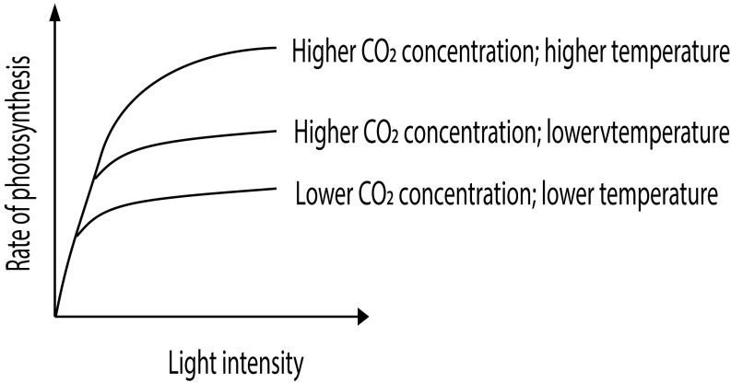

If a higher concentration of carbon dioxide is supplied, light is again a limiting factor and a higher rate can be reached before the rate again plateaus. If carbon dioxide and light levels are high, but temperature is low, increasing temperature will have the greatest effect on reaching a higher rate of photosynthesis.

The leaf
In higher plant the major photo synthetic organ is the leaf.

Functions of the leaves
- Carry out photosynthesis with subsequent production of organic materials
- Carry out gaseous exchange through the stomata
- Transpiration takes place mainly through the leaves resulting in the cooling of plant and absorption of mineral salts and water
- Some leaves such as those of peas are modified by tendrils for support.
- Some leaves suck those bryophyllum are modified for storage
- Some leaves such as for bryophyllum are modified for vegetative reproduction
- Some leaves possess itching hairs, thorns, spikes and poisonous substances for protection of plant.
- Some leaves e.g. Venus fly trap are modified for capturing and extracting nitrogen from animals
- Some produce substances that kill parasites.

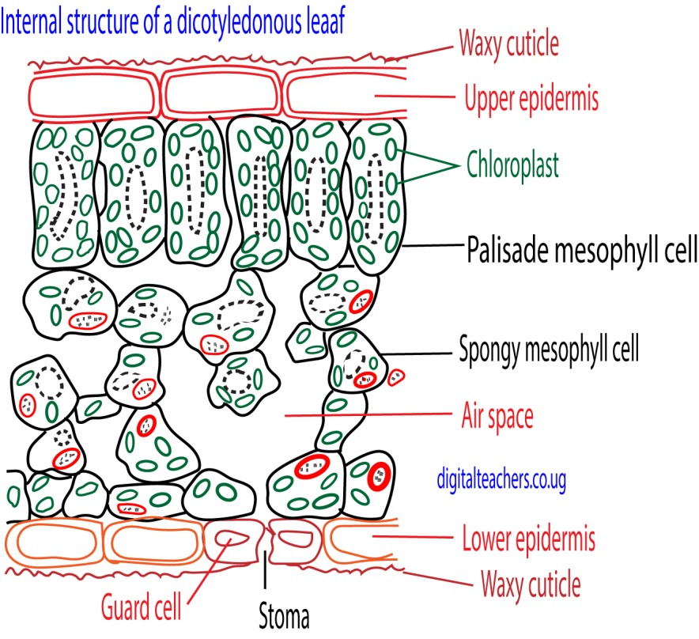

Functions of tissues in dicotyledonous leaves
Tissue | Structure | Function
1. Upper and lower epidermis | One cell thick  External walls covered with cutin (waxy substance) Contain stomata (pores surrounded by guard cells) | - Protective  - Cutin is water proof and reduce water loss from the leaves  - Allow gaseous exchange
2. Palisade mesophyll | Column-shaped cells with numerous chlorophyll in thin layer of cytoplasm | - Main photosynthetic tissue. Chloroplast may move towards light
3. Spongy mesophyll | Irregular shaped cells fitting loosely to leave large air space | - Photosynthetic, but fewer chloroplast than palisade cells. Gaseous exchange can occur through the large air space via stomata.
4. Vascular tissue | Extensive finely branching network through leaf | - Conduct water and  mineral salts to the leaf in xylem  - Remove photosynthetic products through phloem  - Provide a supporting skeleton to the lamina, aided by turgidity

Adaptation of leaves to photosynthesis
- The leaf is only a few cells thick for easy penetration of light and gases.
- Wax cuticle prevent excessive water loss
- The palisade cells that contain numerous chloroplasts are well positioned to receive light.
- Presence of xylem that supply the leaf with water for photosynthesis
- The spongy mesophyll has many air space. Gases can readily diffuse to all photosynthetic cells
- They are broad and flat to offer a large surface area exposed to light and air
- Stomata control passage of gases
- The arrangement of leaves to the plant is such way that each leaf receives light.

Theories that explain the opening of stomata
Several theories explain how stomata open and close, with the current most accepted model being the Active Potassium Ion Transport Theory.
This process is driven by changes in the turgor pressure of the guard cells, which are controlled by light, carbon dioxide levels, water availability, and internal biological rhythms.

Active potassium ion transport theory
This is the modern and most widely accepted theory. It suggests that stomatal opening is primarily driven by the active, energy-requiring influx of potassium (𝐾⁺) ions into the guard cells.
Process in light conditions:
- Light detection: Blue light is sensed by phototropins in the guard cell membranes, while red light is used for photosynthesis in the guard cell chloroplasts.
- Proton pump activation: Light detection activates proton pumps (𝐻⁺-ATPases) on the guard cell membrane, which use ATP to pump protons out of the cells.
- Potassium influx: The movement of protons creates a negative electrical potential (hyperpolarization) across the guard cell membrane. This potential drives the uptake of positive potassium (𝐾⁺) ions into the guard cells through ion channels.
- Counter-ion synthesis: To balance the negative charge created by the proton efflux and the incoming positive 𝐾⁺ ions, the guard cells produce organic acids like malate from starch. They also take in chloride (𝐶𝑙⁻) ions.
- Water influx and turgor: The increased concentration of malate and other solutes lowers the water potential inside the guard cells. Water enters the guard cells from surrounding cells via osmosis, increasing their turgor pressure.
- Stomatal opening: The guard cells swell and, due to their unique radial microfibril arrangement, they bend outwards, causing the stomatal pore to open.
Role of hormones and 𝐶𝑂₂:
- Low 𝐶𝑂₂: Low concentrations of 𝐶𝑂₂ in the leaf's intercellular spaces (due to high photosynthetic activity) also signal the guard cells to open.
- Abscisic acid (ABA): The stress hormone ABA causes stomata to close during drought by inhibiting the proton pumps and promoting the efflux of 𝐾⁺ ions.

Older, less complete theories
Before the details of the active ion transport mechanism were discovered, other theories attempted to explain stomata opening:
- Starch-sugar interconversion theory: This theory proposed that during the day, starch in the guard cells was converted to osmotically active sugars (e.g. glucose). The increased osmotic pressure would cause water to enter, and the stoma would open. At night, sugars would convert back to starch, lowering osmotic pressure and closing the stoma. o Limitations: This theory could not explain the rapid opening and closing of stomata, which happens too quickly for the starch-sugar conversion to be the sole cause. It also failed to explain stomatal movement in some plants that lack guard cell starch.
- Photosynthesis in guard cells theory: This simple theory suggested that photosynthesis in the guard cell chloroplasts produced sugars, increasing the osmotic pressure and causing water influx and opening. o Limitations: The chloroplasts in guard cells are often poorly developed compared to mesophyll cells. This theory was unable to explain why low 𝐶𝑂₂ (a condition not favoring photosynthesis) causes stomata to open, while high 𝐶𝑂₂ causes them to close.
- Glycolate metabolism theory: This theory suggested that under low 𝐶𝑂₂ concentration, glycolate was produced in guard cells. Glycolate could be metabolized to produce sugars or ATP, leading to opening. o Limitations: This theory does not explain why stomata sometimes close in the presence of glycolate or other factors.

Modification of leaves to their functions
- Flattened surface to reduce diffusion distance
- Shiny waxy cuticle to reduce water loss
- Mosaic arrangement to increase light absorption
- modified into tendrils to support weak climbing stems e.g. Gloriosa, peas
- Some leaves are modified into spine in order to reduce water loss. Spines also protect the plant from herbivorous animals
- Some leaves are modified into scale leaves (thin, membranous, dry colourless structures) for protection. E.g. onion outer leaves
- Phyllode : It is a green, expanded structure formed by the modification of petiole or rachis of leaf. Many xerophytes reduce the size of their leaves to minimize water loss. Such plant develop phyllodes to carry out photosynthesis e.g., Acacia, Melanoxylon and Parkinsonia.
- Some leaves are flesh to store water and food
- Some leaves develop vegetative bud for reproduction, e.g. bryophyllum
- In some rootless, aquatic plants, the submerged leaves are modified into root like structure to absorb water and mineral salts. Such modified leaves are called absorbing leaves. e.g., Utricularia.
- Some leaves are brightly coloured to attract insect pollinator, e.g. Bougainville (xii) Some leaves are modified to trap insects.

Experiment to measure the rate of photosynthesis

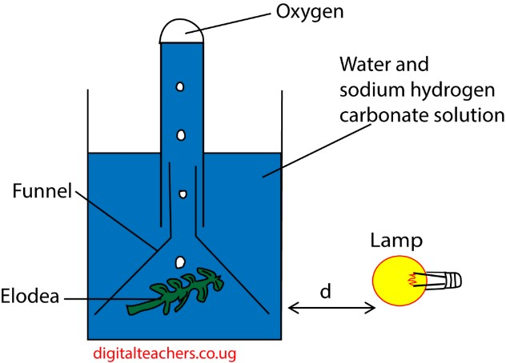

Method
- The apparatus is filled with carbonated water to enrich it with carbon dioxide.
- The setup is allowed to adjust to light intensity for 2-3 minutes. The rate of bubbling should be adequate such as 10 bubbles per minute.
- Light intensity is varied by increasing the distance, d, between the light source and the apparatus such as 10, 15, 20, 40 and 45cm. the bigger the distance, d, the lower the light intensity.
- The rate of formation of bubbles per minute at different distances, d, is an empirical measure of photosynthesis at a given light intensity.
- Temperature change is buffered by using a beaker of bigger capacity.

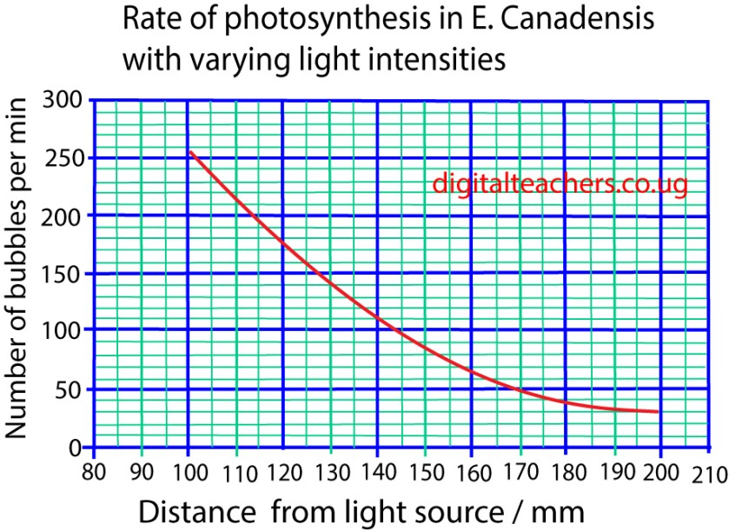

Adaptations to photosynthesize in sun and shade
Shade plant | Sun plant
1. Abundant chlorophyll b (low chlorophyll a to chlorophyll b ratio) which gives leaves dark green colour to increase light absorption in the dark; | 1. Abundant chlorophyll a (high chlorophyll a to chlorophyll b ratio) to increase light absorption;
2. Palisade/ spongy mesophyll ratio low to allow maximum light penetration; | 2. Palisade/ spongy mesophyll ratio high to minimise light penetration;
3. Mesophyll cell surface / leaf area ratio low to maximise light trapping; | 3. Mesophyll cell surface / leaf area ratio high to minimize excessive light and transpiration;
4. Leaf orientation horizontal to maximize light trapping; | 4. Leaf orientation erect to minimize light trapping;
5. Reddish leaf undersides to enhance reflectance back up through the photosynthetic tissue; giving the plant a second chance to utilize the light. | 5. Stomatal density high to avoid over heating;
6. Stomatal density low to avoid over cooling; | 6. Much carotenoids to prevent damage to chlorophyll from very bright light.
7. Thin leaves to maximise light penetration; | 7. Thick leaves to minimise light penetration;
8. Stomatal size large to allow loss of excess water; | 8. Stomatal size small to minimise water loss;
9. Elongated internodes for increased access  to light; | Other features (i) RuBISCO and soluble protein content /mass higher (ii) Chlorophyll / soluble protein ratio high (iii) Chloroplast size small
Types of chemosynthetic bacteria
No. | Nutritional type | Source of energy | Source of carbon | Source of hydrogen | examples
1 | Autotrophic bacteria are classified according to source energy, carbon and hydrogen
(a) | Photoautotrophs | Sunlight | CO₂ | H₂S | Green sulphurbacteria
(b) | Photoautotrophs | sunlight | CO₂ | H₂O | cyanobacteria
(c) | photoheterotroph | Light | Organic compounds | Organic compounds | Purple non sulpur bacteria
(d) | Chemoautotrophs | Inorganic compounds such as NH₃, NO₂, H₂, H₂S | CO₂ | H₂O | Nitrifying bacteria, nitrobacter
2 | heterotrophs | Organic compound | Organic compounds |  | Most bacteria

Importance of bacteria

(1) Harmful effects
- Bacteria are agents of disease of animals and plants such as syphilis, cholera, tetanus
- Bacteria cause milk and food deteriorate
- Denitrifying bacteria such as Thiobacillus lead to deterioration of soil fertility.

(2) Useful effects
- Saprotrophic bacteria cause decay of waste materials and lead to formation of humus and recycling of minerals. E.g. Bacteria (Nitrosomonas and nitrobacter) convert organically combined nitrogen (e.g. protein) to nitrate which are absorbed by plants.
- Nitrogen fixing bacteria e.g. Azobacter fix nitrogen into the soil.
- Aerobic and anaerobic bacteria are useful in digestion of sewage into harmless substances. Methane gas given off is sometimes used for fuel.
- Mutualistic bacteria in ruminants’ assist ruminants to digest cellulose, and synthesis of vitamin K and B group.
- Some bacteria on the skin of humans enable it to obtain protection again inversion of pathogenic organism
- Bacteria and fungi are useful for making of cheese.
- Used for production of useful chemicals in genetic Engineering such as insulin

The significance of chemosynthetic bacteria in an ecosystem
- Chemosynthetic bacteria e.g. Azobacter fix nitrogen into the soil.
- Saprotrophic bacteria cause decay of waste materials and lead to formation of humus and recycling of minerals.
- Chemosynthetic bacteria e.g. Nitrosomonas and nitrobacter convert organically combined nitrogen (e.g. protein) to nitrate which are absorbed by plants.
- They are produce food for other organism in ecosystem

Effects of Light on organisms

Effects light on Plants
- Photosynthesis: Light is the primary energy source for photosynthesis, the process by which plants, algae, and some bacteria produce food (organic matter) from carbon dioxide and water, releasing oxygen in the process. Chlorophyll pigments primarily absorb blue and red wavelengths of light for maximum efficiency.
- Light intensity: Influences stem length (etiolation in low light), leaf size and thickness, and root development.
- Light quality (color): Different wavelengths affect specific processes; blue light promotes leaf and root growth, while red light is more efficient at driving flowering and stem elongation.
- Flowering (Photoperiodism): The duration of light and darkness (photoperiod) dictates the timing of flowering and fruiting in many plants, ensuring reproduction occurs at the most favorable time of year.
- Stomatal Movement: Blue light stimulates the opening of stomata (pores on leaves), which is essential for gas exchange (CO₂ uptake and O₂ release) during photosynthesis and for regulating water loss.
- Phototropism: Plant grow towards light

Effects light on Animals
- Vision: Light is essential for vision in most animals, allowing them to perceive their environment, differentiate colors, find food, and avoid predators. Animals have photoreceptor systems ranging from simple eyespots to complex eyes.
- Circadian Rhythms: The daily cycle of light and darkness is a primary cue (zeitgeber) that entrains the 24-hour biological clocks of animals, regulating sleep-wake cycles, hormone balance (e.g., melatonin and cortisol), metabolism, and immune function. Disruption of this cycle can lead to various health problems.
- Reproduction: Changes in seasonal light duration trigger reproductive cycles and behaviors in many species of insects, fish, birds, and mammals, ensuring offspring are born during favorable conditions.
- Migration and Behavior: Light cues are vital for navigation in migrating animals, such as birds and sea turtles, which use moonlight and starlight for orientation. It also influences movement (phototaxis), with some organisms moving towards or away from light sources.
- Pigmentation: Light exposure is important for skin or plumage coloration and the formation of protective pigments like melanin in the skin of animals, offering protection against harmful UV rays.
- Vitamin D Synthesis: In many animals, including humans, UV light exposure in the skin is necessary for the synthesis of Vitamin D, which is essential for bone health.
- Negative Impacts (Light Pollution): Artificial light at night can disrupt natural behaviors, navigation, breeding rituals, and food webs, leading to disorientation, habitat loss, and increased mortality for many nocturnal species.

Revision Exercise

1. The figure below shows the rate of photosynthesis against light intensity
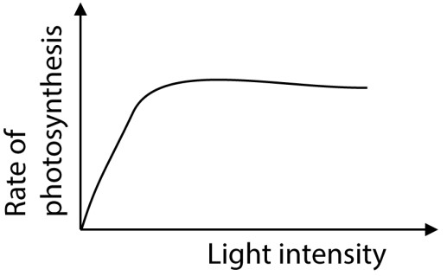

Which one of the following statement is the cause of the flattening of the curve?
- Photosynthetic pigments are saturated
- Too much carbon dioxide is available
- The plant has attained its maximum rate of photosynthesis
- There is a factor other than light which is limiting photosynthesis C 2. Which of the following does not occur during photorespiration?
- Oxygen is used up
- Wasteful loss of carbon as carbon dioxide
- Carbon dioxide is used up
- Wasteful loss of energy C
- The graph below shows the rate of photosynthesis at different light intensities.
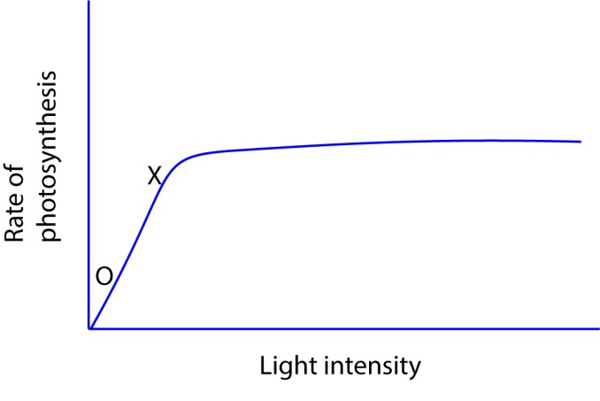
The factor limiting the rate of photosynthesis between O and X is
  - Light intensity B Carbon dioxide.
  - Temperature
  - Oxygen A
* Increase in light intensity increases the rate of photosynthesis
- C3 are less efficient than C4 plants in fixing carbon dioxide at low carbon dioxide and high oxygen partial pressure because
  - C3 plants use more energy
  - In C3 plants, energy is lost
  - RuBP carboxylase is inactivated by high oxygen partial pressure
  - PEP carboxylase has high affinity for oxygen. B
- Photorespiration does not occur in C4 plants because they
  - Use phosphenol pyruvic acid for fixing carbon dioxide
  - Mainly grow at high altitudes
  - Are more abundant in cold region
  - Have succulent leaves which lower the internal temperature A
* PEP carboxylase has a very high affinity for CO₂ and, crucially, does not bind to oxygen (O₂). This means that even in hot, bright conditions where O2levels are high, this initial step of carbon fixation is not inhibited by oxygen.
- Photosynthetic bacterial differ from green plants in that
  - They lack chlorophyll
  - Their source of energy is through oxidation of hydrogen sulphide
  - Their source of energy is through oxidation of iron salts
  - Their source of hydrogen is hydrogen sulphide D
- Net primary productivity in C4 plants is higher than in C3 plants because
  - C4 plants have a higher turn-over rate
  - Energy accumulates at a higher rate in C4 plants
  - Photophosphorylation occurs in C3 plants
  - The rate of respiration is higher in C3 plants B
- Which one of the following curves in the figure below correctly represents plants adapted for low light intensity?

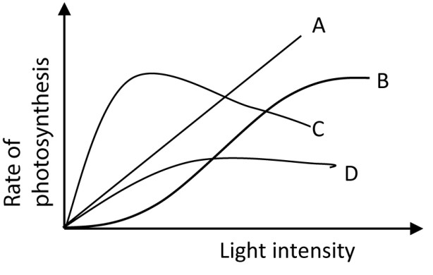 C
C has high rate of photosynthesis at low light intensity

- Which of the following is illustrated in the figure below?
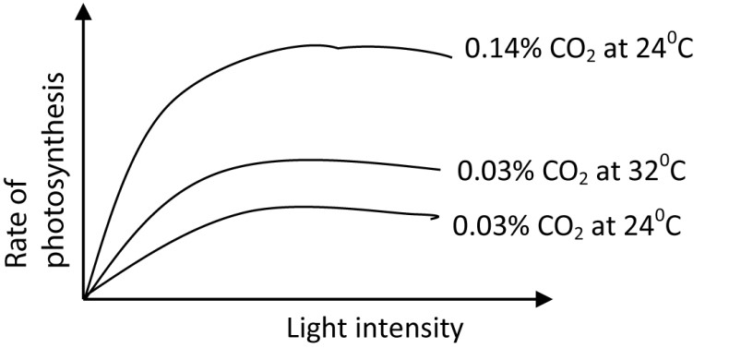

  - With increase in light intensity, the rate of photosynthesis increase until temperature becomes a limiting factor.
  - Rate of photosynthesis increases with an increase in the carbon dioxide concentration
  - With increase in light intensity, the rate of photosynthesis increases indefinitely
  - Rate of photosynthesis increases with an increase in light intensity until carbon
dioxide becomes a limiting factor. D
- Which of the following is likely to occur if a photosynthesizing plant was suddenly removed from light?
  - Reduction in PGA
  - Accumulation of PGAL
  - Accumulation of PGA
  - No change in amount of PGAL C
* Production of ATP and NADPH stops in the dark, hence PGA accumulates because it is no longer reduced.
11 In which part of the following parts of a chloroplast are water splitting enzymes mostly located?
- Stroma
- Intergrana C Cytoplasm
D Grana D
* The water-splitting enzyme complex, also known as the oxygen-evolving complex, is part of Photosystem II. This photosystem is embedded in the thylakoid membranes of the grana, where it uses light energy to split water molecules
- Etiolation in plants is usually a response to
  - Insufficient nutrients
  - Low temperature
  - Insufficient light
  - Too much water. C

- In photosynthesis, the major advantage of the C4 pathway is to
  - Fix carbon dioxide in the Calvin cycle
  - Concentrate carbon dioxide in the cells of leaves
  - Fix carbon dioxide from the atmosphere into the leaves
  - Store carbon dioxide in form of organic acids B
* CO₂ concentration mechanism: The C4 pathway uses a preliminary fixation step with the enzyme PEP carboxylase in mesophyll cells. The fixed carbon is then transported as a 4-carbon compound to the bundle sheath cells, where CO₂ is released. This process effectively creates a much higher concentration of CO₂ around the RuBisCO enzyme than what is available in the atmosphere.
14 During the light stage of photosynthesis, water is important in that it
- Gives of oxygen
- Provides hydrogen that reduce NAD
- Reduces carbon dioxide to carbohydrates
- Provides electrons D
15. Figure below shows the relationship between temperature and rate of photosynthesis in two species A and B.
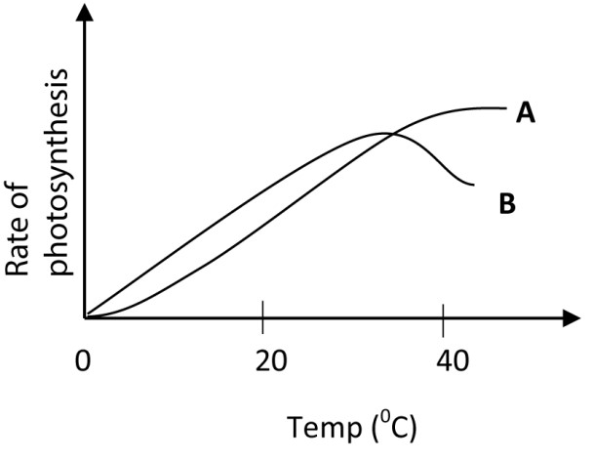
Which one of the following is correct conclusion from the results?
- B is a shade plant while A is a sun plant
- A has a lower compensation point than B
- A has a higher optimum temperature for photosynthesis than B
- Photorespiration does not occur in A but occurs in B C 16 Which of the minerals nutrient are constituents of chlorophyll?
- Potassium and sulphur
- Nitrogen and magnesium
- Calcium and phosphorus
- Zinc and copper B
- Photosynthetic bacteria differ from plants in their nutrition in that the bacteria A Derive their energy from oxidation of ammonia
  - Obtain hydrogen for reduction of carbon dioxide from hydrogen sulphide
  - Possess chlorophyll b to trap sunlight
  - Oxidise hydrogen sulphide to obtain energy B
- Which one of the following is the role of reduced NADP in the dark stage of photosynthesis?
  - Combines with carbon dioxide
  - Provide energy
  - Provides hydrogen
  - Acts as an electron acceptor C
* NADPH donates its hydrogen atoms (which include electrons and protons) to reduce 3-phosphoglycerate (PGA) into glyceraldehyde-3-phosphate (PGAL, or G3P).
- Which one of the following colours of light are most effective in photosynthesis?
  - Green and red
  - Blue and red
  - Blue and yellow
  - Blue and green B
* Chlorophyll pigments absorb light most strongly in the blue-violet and redorange regions of the visible light spectrum.
- Which wavelength from light spectrum is mostly absorbed by green plants?
  - brown
  - Green
  - Blue
  - Yellow C
- Where in the cell does the reduction of carbon dioxide occur during photosynthesis?
  - Lamella
  - Stroma
  - Quatasome
  - Grana membrane B
* Stroma contains the enzymes, including RuBisCO, necessary for the light-independent reactions (Calvin cycle) of photosynthesis. Carbon dioxide is "fixed" to a molecule (RuBP) and then reduced to sugar phosphates in the stroma.
- During what stage of the dark reaction is NADPH₂ used? Conversion of
  - Ribulose diphosphate to phosphoglyceric acid
  - Phosphoglyceraldehyde to hexose sugar
  - Hexose sugar to starch
  - Phosphoglyceric acid to Phosphoglyceraldehyde D
* NADPH donates its hydrogen atoms (which include electrons and protons) to reduce 3-phosphoglycerate (PGA) into glyceraldehyde-3-phosphate (PGAL, or G3P).

- The figure blow illustrates the phenomenon of limiting factors. What, in this case, is the limiting factor for photosynthesis?
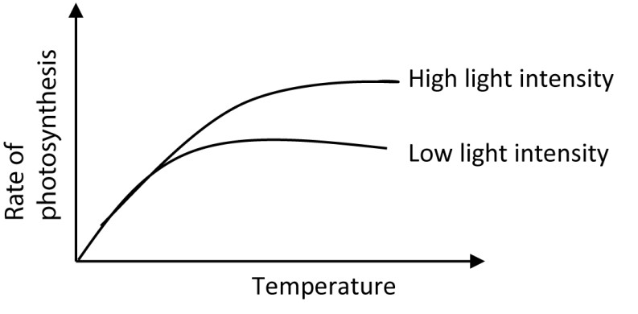
  - Chlorophyll content
  - Temperature
  - Carbon dioxide
  - Light D
* Increase in light intensity increases the rateofphotosynthesis
- Which of the following occurs during the light dependent stage of photosynthesis?
  - Formation of ADP
  - Formation of NADPH₂
  - Formation PGAL
  - Production of NAGP⁺ B
* During this stage, light energy is converted into chemical energy, primarily in the form of ATP and NADPH.
- Which of the following pairs of reactants is not required for the lightindependent reaction of photosynthesis?
  - NADPH and ATP
  - ATP and carotenoid
  - RuBP and free oxygen
  - Carbon dioxide and enzymes A
* NADPH is sometimes represented as NADPH₂
- The first carbohydrate made in photosynthesis is
  - Ribose sugar
  - Ribulose
  - Phosphoglyceric acid
  - Phosphoglyceraldehyde D
- In photosynthesis, the major advantage of the C4 pathway is to
  - Fix carbon dioxide in the Calvin cycle
  - Concentrate carbon dioxide in the cell of leaves
  - Fix carbon dioxide from atmosphere into the leaves
  - Store carbon dioxide in form of organic acid D
- During the light stage of photosynthesis, water is an important raw material in
that it
  - gives off oxygen
  - Provide hydrogen that reduces NAD
  - Reduce carbon dioxide to carbohydrate
  - Provides electron D
- During water stress, photosynthesis reduces in plant mainly due to shortage of
  - carbon dioxide
  - mineral salts
  - Water
  - Sunlight A
* Due to closure of stomata to reduce water loss
- A close relationship between the action spectrum for photosynthesis and absorption spectrum of the chlorophylls indicate that
  - All the light absorbed by the chlorophylls is used in photosynthesis
  - Chlorophylls are responsible for absorption of light in photosynthesis
  - Photosynthesis proceeds after light absorption
  - Light energy is trapped in chlorophylls. B
* Absorption Spectrum: This graph shows the wavelengths (colors) of light that a particular pigment (like chlorophyll) absorbs most effectively.
Action Spectrum: This graph shows the overall rate of photosynthesis at different wavelengths of light.
The Correlation: The fact that the peaks of the action spectrum (highest rate of photosynthesis) closely match the peaks of the absorption spectrum (highest light absorption by chlorophyll) demonstrates that the light absorbed specifically by the chlorophyll pigments is the light that is actively driving the process of photosynthesis.

- The products of light reaction in photosynthesis are
  - NADH₂, ATP and O₂
  - NADP, ATP and O₂
  - NADPH₂, ADP and O₂
  - NADPH₂, ATP and H₂ A
- Which one of the following stages of photosynthesis uses light energy directly?
  - Regeneration of ribulose diphosphate
  - Production of energy in the form ATP
  - Reduction of carbon dioxide
  - Formation of phosphoglyceric acid B
- Which one of the following is the main form of photosynthetic product transported by the phloem?
  - Starch
  - Amino acids
  - Sucrose
  - Glucose C
- The difference between a green plant and the iron bacteria in synthesis of organic compound is that
  - Bacteria derive their energy for synthesis from oxidation of inorganic compounds
  - Source of hydrogen for the bacteria is not water
  - Bacterial have a different kind of chlorophyll
  - Bacteria lack enzymes for fixing of carbon dioxide A 35. Which of the following stages of photosynthesis use light energy?
  - Regeneration of ribulose diphosphate
  - Production of energy in form of ATP
  - Reduction of carbon dioxide
  - Formation of phosphoglyceric acid B
36. The organism that require only inorganic raw materials from the environment is
- Virus
- Amoeba
- Euglena
- Plasma C
* Euglena requires water, carbon dioxide, and sunlight for photosynthesis
37 If carbon containing radioactive carbon was added to a suspension of photosynthesising algae, in which one of the following compound would the radioactive carbon show first?
- Glucose
- Phosphoglyceric acid
- Ribulose bisphosphate
- Triose phosphate B
- The table shows the effect of temperature on the rate of apparent
photosynthesis and respiration in plants
Temperature (⁰C) | 7 | 10 | 15 | 19 | 22 | 28
Rate of apparent photosynthesis  (mgCO2g-1h-1) | 1.3 | 2.3 | 2.8 | 3.1 | 2.8 | 2.5
Rate of respiration (mgCO₂g⁻¹h⁻¹) | 0.3 | 0.6 | 0.7 | 1.2 | 1.8 | 2.1
The temperature in ⁰C, at which the plant is least efficient photosynthetically is
  - 7
  - 10
  - 22
  - 28 D
* At 28⁰C, plant has least net gain in carbon (CO₂)
- The figure below shows the relationship between temperature and the rate of photosynthesis in two plant species A and B.
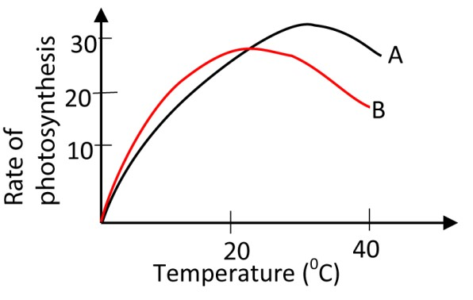
Which one of the following is the correct conclusion from the result? A B is a shade plant while A is a sun plant
  - A has a lower compensation point than B
  - A has a higher optimum temperature for photosynthesis than B
  - Photorespiration does not occur in A but occurs in B C
40 The figure below shows the variation of rate of photosynthesis with light intensity
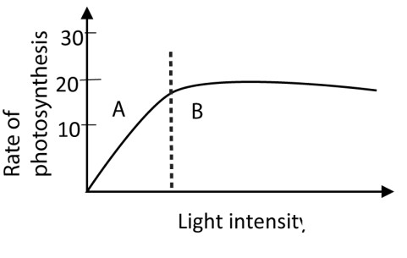
The factor limiting the rate of photosynthesis in region A is
- Light intensity
- Carbon dioxide concentration
- Water
- Temperature A
* Increase in light intensity increases the rate of photosynthesis 41 Which of the following action is most affected by low temperature?
- Absorption of light
- Splitting of water
- Fixation of carbon dioxide
- Formation of ATP C
* Photosynthesis is divided into two main stages: the light-dependent reactions and the light-independent reactions (Calvin cycle).
The light-dependent reactions (absorption of light, splitting of water, and formation of ATP) are primarily photochemical processes and are not highly sensitive to temperature changes.
The light-independent reactions (the Calvin cycle), which includes the fixation of carbon dioxide, are a series of enzymatic reactions. The rate of enzymecatalyzed reactions is highly dependent on temperature.
Low temperatures significantly slow down the activity of the enzymes involved in the Calvin cycle (such as RuBisCO), thus limiting the rate at which carbon dioxide can be fixed and reduced. Therefore, the fixation of carbon dioxide is the step most affected by low temperature.

- The figure below shows the rate of photosynthesis of a plant at varying conditions.
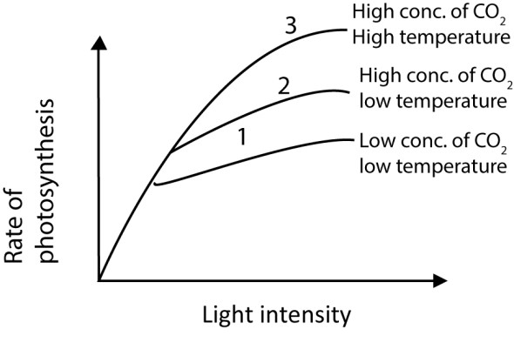
Which factor is limiting photosynthesis in curve 2
  - Carbon dioxide concentration
  - pH
  - Light
  - Temperature D * Increasing temperature increase the rate of photosynthesis
- Which one of the following if increased to an Eldea plant in water at 30⁰Cwould lead to a rise in number of bubbles released from the plant
  - Light
  - Temperature
  - Wind velocity
  - Humidity A
* • The bubbles released from an Elodea plant during photosynthesis are oxygen (O₂) gas. The rate at which bubbles are produced is a measure of the rate of photosynthesis.
    - The plant is already at 30, which is likely near or at the optimal temperature for the enzymes involved in photosynthesis.
    - Increasing Light: If light is a limiting factor, increasing the light intensity will increase the rate of photosynthesis, and thus increase the number of oxygen bubbles produced. In a typical experimental setup under controlled conditions, light is often the limiting factor when other factors are optimal.
    - Increasing Temperature: Increasing the temperature beyond the optimal 30C would likely denature the enzymes and reduce the rate of photosynthesis, not increase it.
    - Wind Velocity & Humidity: Wind velocity and humidity primarily affect transpiration

- Figure below shows the rate of photosynthesis against light
Which one of the following statements is the cause of flattening of the curve?
  - Photosynthetic pigments are saturated with light
  - To much carbon dioxide is available
  - Plant has attained maximum rate of photosynthesis
  - There is a factor other than light which is limiting the rate of photosynthesis D

Structured questions
- Figure 7 show the concentration -3 phosphate (GP) and ribulose bisphosphate (RuBP) during an investigation in which a sample of chlorella was allowed to photosynthesis at very low and very high carbon dioxide levels.
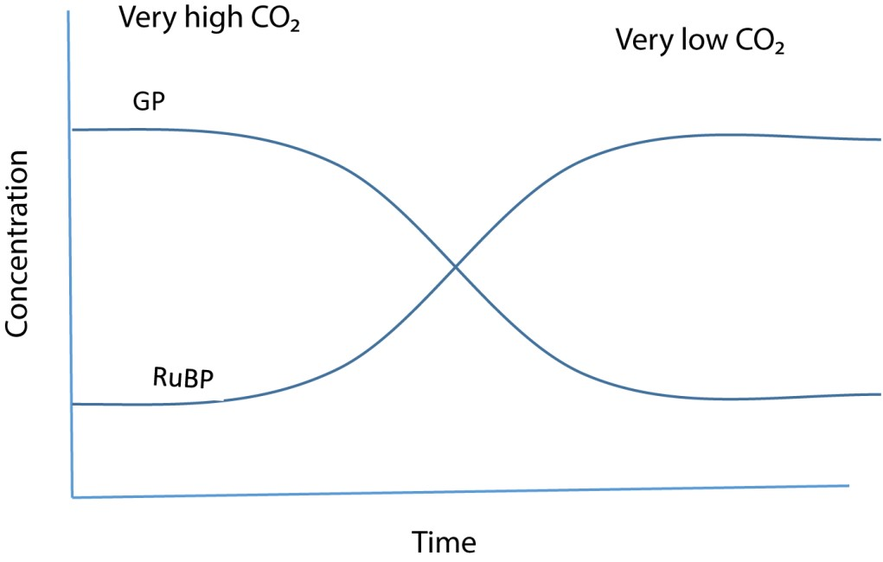
  - Explain the change in concentration of RuBP at
  - High carbon dioxide levels
The concentration of RuBP is low. This is because RuBP combines with carbon dioxide and water to form glycerate- 3 phosphate (GP).
Note:
RuBP + CO₂ + H₂O RuBP carboxylase 2GP

  - Very low carbon dioxide levels
The concentration of RuBP is high. This is because RUBP is being regenerated from triose phosphate, but since carbon dioxide concentration is low, RuBP is not being used hence it accumulates
  - Suggest why the concentration of GP falls when the levels of carbon dioxide is reduced
Carbon dioxide combines with RuBP in the presence of RuBP carboxylase to generate GP. Hence low carbon dioxide levels lead low rate of formation of GP
  - Name two factors which must have been kept constant in the investigation
Temperature
Light intensity

  - Give four difference between cyclic and noncyclic photophosphorylation

Cyclic photophosphorylation | Non – cyclic photophosphorylation
Involves cyclic pathway of electrons. | Involves non –cyclic pathway of elections.
Photo system 1 is the first electron donor | Water is the first electron donor
Photo system 1 is the last electron acceptor | NADP is the last electron acceptor
Product is ATP only | Products are ATP, reduced NADP and oxygen.
Others  Only photo system 1 is involved | Bothe photo system 1 and 11 are involved.

Note: phosphorylation is the process by which ATP is synthesized from ADP and an inorganic phosphate using energy.
In photosynthesis the energy is supplied by light, hence the process is called photophosphorylation. It can be cyclic or non- cyclic
The ATP is formed is formed in the light-dependent stage is used to transfer energy to the light independent stage.
- (a) What is chemosynthesis? (1mark)
Chemosynthesis is the process by which organic compounds are synthesized from inorganic raw material using energy from oxidation of inorganic compounds.
  - Outline three ways in which photosynthesis in purple sulphur bacteria differs from that of higher plants (3marks)
Purple sulphur bacteria | Higher plants
Source of hydrogen (reducing power) is hydrogen sulphide. | Source of hydrogen (reducing power) is water
Produce solid globules of sulphur as biproduct. | Produce O₂ as bi-product
Use bacteriochlorophyll as the pigment | Use chlorophyll as the pigment

  - Explain why it is possible for photosynthetic and chemosynthetic bacteria to co-exist in an oxygen free environment? (3marks)

Photosynthetic bacteria release oxygen during photosynthesis, which they both use in respiration. They also produce organic compounds which are used by the chemosynthetic bacteria for metabolism.
Chemosynthetic bacteria produce inorganic substrate like hydrogen sulphide which are used by the photosynthetic bacteria in their metabolism
  - State the importance of chemosynthetic bacteria in nature. (3marks)
    - Chemosynthetic bacteria are important in the decomposition of nitrogenous waste in the environment and thus enrich the soil and water with nutrients.
    - They release energy in their metabolism that is used by other organism in synthesis of organic compounds.
    - They are producers manufacturing organic compounds that can be utilized by other organism.
- The figure below shows light saturation curves of photosynthesis for plants of the same species growing under different light intensities.



O

Region Y
CO
2

uptake

µmolh
-
1
dm
-
2

Light intensity

Light plants

shade plants

P

  - Compare the effect of intensity on the carbon dioxide uptake in the two types of plants. (4marks)
Similarities
Carbon dioxide uptake increase initially at low light intensities and the decreases gradually at higher intensities, to reach constant valves.

Differences
Light plants | Shade plants
- Initial rate of carbon dioxide uptake is high at low light intensities  - Carbon dioxide uptake starts below zero.  - reach a constant at a higher light intensity.  - higher saturation value | - Initial rate of uptake carbon dioxide is high at low light intensities  - Carbon dioxide uptake starts at zero  - reach a constant at a lower light intensity.  - lower saturation value

  - Describe the state of the light plants at point P. (2marks)
The plant is in a state of compensation point at point P. Here is no net uptake of carbon dioxide because the rate of photosynthesis equals the rate of respiration.
  - Explain what happens to the plant biomass in region Y. (2marks)
In region Y the plant biomass decrease
Explanation
The rate of respiration of the plants is higher than photosynthesis. There is more food breakdown than synthesis.

  - State an environmental factor that affects the shape of the graph other than carbon dioxide (2marks) Temperature

- (a) How does the synthesis of organic compounds in photosynthetic bacterial differ from that in
(i) Green plants (2marks)

      - The hydrogen for reducing carbon dioxide comes from hydrogen sulphide while in green plants, the hydrogen come from water.
      - Oxygen is not given off during the synthesis of organic compounds in photosynthetic bacteria as it is in green plants

(ii) Chemosynthetic bacterial? (2marks)

      - They obtain energy from sunlight while chemosynthetic bacteria obtain the necessary energy from oxidation of inorganic compounds other than sugar.
      - They do not give off any gaseous product during the processes while some chemosynthetic bacteria give off methane gas.

(b) The figure below shows a scheme of reactions occurring in a chroplast during photosynthesis.



NADP
2
B

ATP

A

Calvin

Light

W X

Y Z

(i) Name the chemical substances represented by letters W, X, Y and Z (2marks) W-water
X- oxygen
Y – Carbon dioxide
Z- phosphoglyceradehyde (PGAL)/carbohydrate
(ii) Indicate by means of arrows on the diagram, the direction of transfer of substances occurring in cycles A and B (1mark)

NADP
2

B

ATP

A

Calvin

Light

W X Y Z

[NB: The candidates should indicate the arrow on the diagram in the question.
(c) State three adaptations of a chloroplast for photosynthesis. (3marks)

- It contains chlorophyll molecules which trap sunlight energy for use in the process of photosynthesis.
- it contains thylakoid membranes arranged into coin-like stacks called grana to increase surface area for packaging of chlorophyll molecules
- it contains enzymes necessary for fixation of carbon dioxide.
49. Figure below shows the distribution of C3, C4 and CAM plants at altitudes

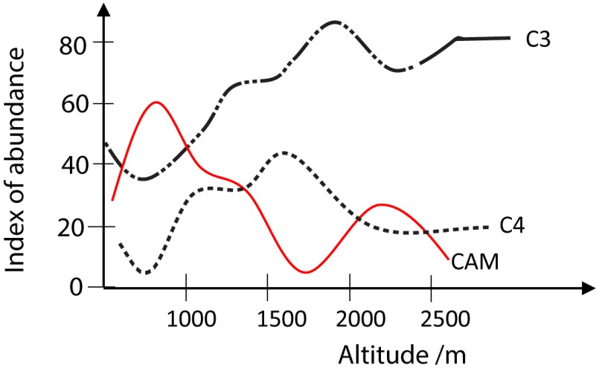
- Suggest reasons for the trends in the distribution of each of the plants
  - C3 plants (2marks)

Are more abundant at high altitude. Reason (s)
At high altitude, the partial pressure of oxygen and temperature are lower. This reduces competition between carbon dioxide and oxygen for RUBP carboxylase enzyme and enhance carbon dioxide fixation. Thus, C3 plants are more abundant at high altitude where they can photosynthesis more efficiently at low temperature
  - C4 plants (2marks)

Are more abundant at mid-altitude levels Reason (s)
due favorable mild temperature
NB PEP carboxylase is not affect by oxygen concentration, temperature is the major limiting factor of photosynthesis in C₄ plants.
  - CAM plants (2marks)

Are more abundant at low attitudes
Reason (S)
CAM plants adapted to photosynthesizing more efficiently at higher temperatures. Such temperature can only be experienced at low altitudes, explaining their more abundance there.
- State four physiologic differences between C3 and C4 plants (4marks)
C₃ plants | C₄ plants
Carbon dioxide acceptor is RUBP  First stable product is PGA  Photorespiration occurs  Requires 18 ATP for the synthesis of one glucose molecule | Carbon dioxide acceptor is PEP  First stable product is Oxaloacetic acid (OAA).  Photorespiration does not occur.  Require 30 ATP for the synthesis of one glucose molecule.

50. The figure below shows the variation of the rate of photosynthesis with temperature in C3 and C4 plants, at different light intensities
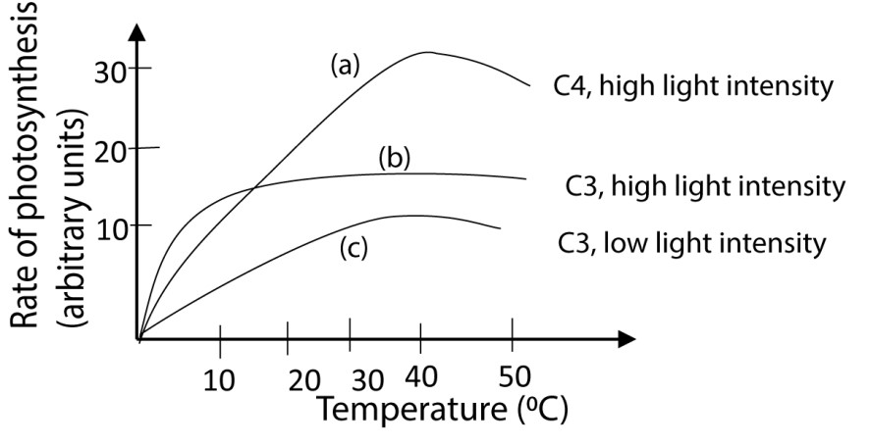
- Using the figure, state how different temperatures affect the rate of photosynthesis in
C3 plants from C4 plants at high light intensity.
(3marks)
C3 plants | C4 plants
Optimum temperature (35⁰C) is lower | Optimum temperature (40⁰C) is higher
Low maximum rate | High maximum rate
At temperature below 10⁰ C, C₃ plants have a higher rate of photosynthesis than C₄ plants | At temperature below 10⁰ C, C₃ plants have a lower rate of photosynthesis than  C₃ plants
At temperature above 20⁰ C, the rate of photosynthesis in C₃ plants is lower than that in C₄ plants. | At temperature above 20⁰ C, the rate of photosynthesis in C₄ plants is higher than that in C₃ plants.

- Explain the differences in the effect of temperature on the rate of photosynthesis in C3 and C4 plants at high light intensities stated in (a) (03marks)
  - In C₃ plants, plants, increase in temperature reduces the affinity of RUBP carboxylase for carbon dioxide but increase its affinity for oxygen. As a result, more CO₂ is lost and less is fixed photosynthesis.
  - PEP- carboxylase’s affinity for carbon dioxide in C₄ is not affected by temperature. Instead, temperature increases the rate of the enzyme action by increasing the kinetic energy of the reacting molecules and enhances the process of photosynthesis.

- Explain the pattern of curve C in the figure above. (04marks)

Rate of photosynthesis increases gradually, until a maximum at about 35⁰ C and then decreases rapidly at higher temperature.

Explanation
- The rate of reaction increase with temperature up to 35⁰C the optimum temperature because the enzymes are being activated
- The maximum rate attained is low because at high temperature, RUBP carboxylases gives up CO₂ and pick up O₂. CO₂ then lost in photorespiration.
- Above the optimum temperature the rate drops because the enzymes are denatured.

- (a) Giving examples, differentiate between photosynthetic and chemosynthetic bacteria.

Photosynthetic bacteria manufacture carbohydrates from hydrogen sulphide, carbon dioxide using light energy. Example is cyanobacteria (H₂S) as electron donor instead of water
CO₂ + 2H₂S C(H₂O) + 2S They do not give off oxygen
Chemosynthetic bacteria manufacture carbohydrates from water and carbon dioxide using energy from oxidation of chemicals such as ammonia. Example is nitosomonas, iron bacteria, hydrogen bacteria

  - Explain how certain bacteria which require light for photosynthesis, survive under weeds in ponds and rocks
The bacteria chlorophyll absorb light of different wavelengths optimum for photosynthesis from that used by the plants thus, bacteria find the spectrum useful after the plants have filtered out light for photosynthesis. Secondary, the rocks supply hydrogen sulphide.
- (a) Name the two stages of photosynthesis indicating where, in the chloroplast, they occur.
    - light stage occurs in thylakoid membranes
    - dark stage occur in stroma

(c) By means of a flow diagram, show the sequence of electron flow during noncyclic photophosphorylation.

Non cyclic photophosphorylation
Chlorophyll molecule PSII is struck by light, an electron is excited and captured by an electron acceptor, passes through an electron carrier system and handed to chlorophyll molecule PSI
The flow of electrons from PSII to PSI in thylakoid membrane causes accumulation of H⁺ inside the thylakoid space creating a gradient. The passage of H⁺ out of the thylakoid provides energy to synthesise ATP.

- (a) What is photophosphorylation? (2marks)
Photophosphorylation is the formation of ATP from ADP and inorganic phosphate using sunlight as the source of energy.
  - Where in the plants cell does cyclic photophosphorylation occur (2mark) Cyclic photophosphorylation occurs in thylakoid membranes in chloroplast. (c) Describe the process of cyclic photophosphorylation (5marks)
    - Light strikes chlorophyll molecule PSI
    - an electron is excited, passes through electron carrier system and return to PSI
    - in the process, H⁺ builds up in the thylakoid space creating a gradient. Then the passage of H⁺ out of the thylakoid provides energy for synthesising ATP.

(d) Importance of cyclic photophosphorylation in photosynthesis. (2marks) Produces ATP when NADPH is not necessary
- (a) Name the organelle most important in photosynthesis and respiration
    - Photosynthesis - chloroplast
    - Respiration - mitochondria
(b) Give four differences and five similarities between the two organelles (i) Differences

Mitochondria | chloroplast
Has no chlorophyll | Has chlorophyll
Break down sugars | Synthesise sugars
Inner folding called cristae | Inner folding called thylakoid membranes
colourless | Green
Bean shaped | Disc shaped
Present in plants and animal | Present in plants

(ii) Similarities
        - Both have circular DNA
        - Both have a double membrane
        - Both have extensive membrane system
        - Both have a matrix
        - Both produce ATP
        - Both reproduce by cell division

- The figure below shows the effect of temperature on the rates of photosynthesis and respiration in well illuminated leaves
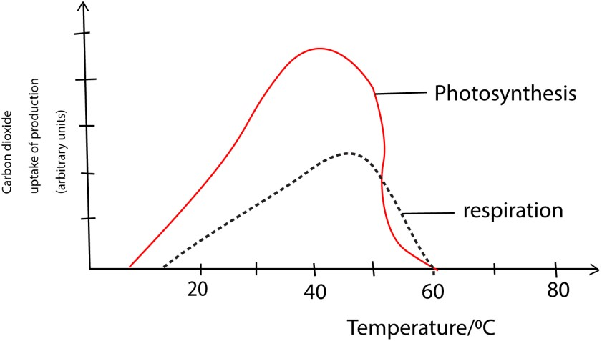
- Compare the effect of temperature on the rates of photosynthesis and respiration.
(04marks)
similarities
  - In both photosynthesis and respiration, the rates increase to the maximum and then drop to zero.
  - Both have equal CO₂ uptake/production at 50⁰C and 60⁰C. Differences
  - The rate of photosynthesis starts to rise at a lower temperature than in respiration
  - The rate of photosynthesis reaches a maximum at a lower temperature (40⁰C) than that of respiration (45⁰C).

- Explain the shapes of the curves (06marks)
Explanation
  - In both, the rate of photosynthesis and respiration increase with temperature to the maximum because the enzymes become more active as temperature increases.
  - After the maximum the rates decrease because the enzymes are denatured by high temperature.
  - The maximum rate of photosynthesis is reached at lower temperature because the enzymes for photosynthesis have lower optimum temperature.
  - Photosynthesis consumes more carbon dioxide than produced by respiration because some sugars are stored and not respired.

Paper 2 revision questions
56. (a) Giving examples in each case, explain what is meant by each of the following
  - Saprophytes (2½ marks)
Saprophytes are organisms which feed on dead/decaying organic matter.
Examples include bacteria, fungi and protists.
  - Chemoautotrophs (2½ marks)
Chemoautotrophs are organisms which synthesis organic matter using energy obtained from oxidation of inorganic materials such as ammonia. For example, nitrosomonas and nitrobacter
(b) Compare saprophytes and parasites (10marks)

Similarities
- Both are heterotrophic
- Both produce large number of offspring.
- Both have sexual and asexual phases in their reproductive cycle.
- Both have digestive enzymes.

Differences
Saprophytes | Parasites
Derive energy from decaying organic matter | Derive energy from living organisms
Involve a single adult stage and spores in life cycle | Involve many stages in their life cycle
Use a variety of food sources | Usually very specific to their hosts
Have simple method of nutrition | Have a complex method of feeding
Almost totally bacteria and fungi | Most plant and animal groups have representatives
There are aerobic and anaerobic forms. | Most are aerobic

(c) Explain the importance of saprophytism to human life (5marks)
Saprophytism is important to human life in the following ways;
- Recycling of materials by feeding on decaying organic matter, the saprophytes
unlock and recycle nutrients which would otherwise have been lost with the dead organisms.
- Decomposition of sewage or waste; saprophytes aid the decomposition of waste produced by human activities. By this the bulk of the waste is reduced and nutrients made available to crops.
- Some saprophytes, especially fungi are used as food by man.
- Physiological processes of saprophytism and as fermentation are useful in brewing and baking.
- The production of yoghurt and cheese from milk also employs saprophytic mechanisms.
- Some saprophytes are used in the production of antibiotics.
- Industrial processes such as leather tanning and production of some vitamins make use of saprophytic organisms.
- (a) How is the chloroplast suited for its function? (08 marks)

      - It contains chlorophyll molecules which trap sunlight energy to be used in of photosynthesis.
      - It contains thylakoid membranes arranged into coin-like stacks called grana to increased surface area for packaging of chlorophyll molecules.
      - It contains enzymes necessary for fixation of carbon dioxide.
      - Contain thin membrane for diffusion of gases
  - Describe the modification of the parenchyma tissue in different parts of a plant, to suit its function. (05marks)

      - In roots (e.g., carrots, sweet potatoes), stems (e.g., potatoes, sugarcane), fruits (e.g., apples, pears), and seeds the parenchyma are modified for storage. The cells are large, often lack chloroplasts, and contain a large central vacuole that can store a variety of substances.
      - Due to presence of storage granules and intercellular spaces, they absorb water, become turgid and tightly packed and so provide support for the organs in which they form the main means of support.
      - In floating plant roots, stems and leaves Parenchyma cells develop large, interconnected air spaces (aerenchyma or canals between them) for providing buoyancy.
      - A system of air spaces runs from the external environment where they open as stoma (in leaves) or lenticel (in stems). These air spaces run between cells and allow gaseous exchange to take place between living cells and the external environment.
      - Parenchyma cells may be flattened to form a one-cell thick layer that covers most parts of the plant as epidermis. This is usually covered with wax and helps to protect the plant from desiccation.
      - Photosynthetic parenchyma, also called collenchyma, contains chlorophyll that traps light energy for the process of photosynthesis. It is usually found in the palisade layer of leaves exposed to sunlight.
      - Companion cells are specialized parenchyma cells found adjacent to sieve tubes and are vital for the functioning of the latter. They are very active metabolically and how the denser cytoplasm, larger nucleus and smaller vacuoles than normal parenchyma cells denser exposed to sunlight.
      - Secretory Cells: Some parenchyma cells are modified to produce and secrete substances like nectar, resins, or oils.

  - Explain the distribution of mechanical tissue in plants. (7marks)

Mechanical tissues in plants constitute the tissues that are responsible for supporting the plant above the ground.
    - In the non-woody herbaceous plants, parenchyma serves as the mechanical tissue. It is distributed in the cortex, pith and packing tissue in xylem and phloem. In this position they offer support to the stem when turgid and keep it above the ground.
    - In woody plants, mechanical tissue consists of collenchyma and sclerenchyma which has more mechanical strength than parenchyma is located in the cortex, pith, phloem and xylem at this position, they provide enough tensile and compressional strength that allows the woody plants to withstand the stresses of the atmosphere.
    - Sclerenchyma and collenchyma tissue also form mechanical tissue around the vascular bundles. This allows the vascular bundles to remain open in order to continually transport material within the plant.
- (a) Explain how plants living under the canopy of forest trees are able to survive
(15marks)
    - Some have adopted a parasitic mode of life and are found developing from the stems of tall forest trees as epiphytic feeders.
    - Some have climbing stems. This makes them capable of reaching out to light by growing their leaves beyond the forest canopy.
    - Some have breathing roots that grow up from the water logged soils to allow for proper gaseous exchange.
    - Some plants such as the ferns have tissues that are well adapted to live in the water logged soils of the forest.
    - Some plants are well adapted to photosynthesize at low light intensities below the forest canopy.
    - Some plants form symbiotic relationships with the forest trees and other saprophytic organisms (such as fungi) in order to obtain enough nourishment.
    - Some have adopted C₄ photosynthetic pathway, making them more efficient at photosynthesis.
    - Most plants have a higher chloroplast density in their leaves compared to the tall forest tress. This makes them efficient at trapping the low light that reaches them below the forest canopy.
    - Some plants are more efficient at trapping and utilizing light of different wavelength from that trapped by the tall trees. Thus, they can still be able to receive this after the tall trees have trapped the rest from the light spectrum.
    - Some of the plants such as the insectivorous plants are heterotrophic feeders and so require a minimum amount of light which they can sufficiently receive
even below the forest canopy.
    - Most plants possess an extensive surface root system in order to obtain enough aeration in the water logged forest soils.
    - Most plants are seasonal with short life cycle, growing only when conditions are favorable especially when deciduous trees lose leaves and allow penetration of light.
    - Some plants are able to adjust the angle of their leaves towards light

  - Describe how herbaceous plants are supported of the ground. (5marks)

After the absorption of water, the cells in the plant become turgid because of the relatively inelastic cellulose cell wall. This results in a firm tissue which provides mechanical support to the plant. This is supplemented by smaller quantities of mechanical tissues (collenchyma, sclerenchyma and xylem)

- (a) Compare photosynthesis and aerobic respiration. (9marks) Similarities
  - Both are energy converting processes.
  - Both require mechanisms for exchange of carbon dioxide and oxygen.
  - Both processes have a reaction pathway in which ATP is formed i.e. photo phosphorylation and oxidation phosphorylation in photosynthesis and respiration respectively.
  - Bother processes involve enzyme-controlled reactions.
  - Both require special organelles in eukaryotes, chloroplasts for photosynthesis and mitochondria for respiration.
  - Both processes are affected by temperature.

Differences
Aerobic respiration | Photosynthesis
A catabolic process (involves breakdown of carbohydrates into simple of sugar) inorganic compounds. | An anabolic process which results in synthesis of carbohydrate molecules from simple inorganic compounds.
Energy is incorporated into ATP for immediate use | Energy is accumulated and stored in carbohydrates
Oxygen is used up | Oxygen is released
Carbon dioxide and water are released | Carbon dioxide and water are used up
Process occurs in decrease in dry mass | Results in increase in dry mass
Process occurs in mitochondria in eukaryotes | Process occurs in chloroplast in eukaryotes
Takes place continuously throughout life and is independent of chlorophyll and light | Occurs only in cells possessing chlorophyll and only in the presence of light.

- Explain the effect of low oxygen tension on
  - C3 plants (3marks)
Low oxygen tensions stimulate photosynthesis in C₃ plants due to reduced competition between oxygen and carbon dioxide for the active site of ribulose -1, 5biphosphate (RUBP) carboxylase enzyme.
  - C4 plants (2marks)
Low oxygen tensions have no effect on the rate of photosynthesis in C₄ plants because the active site of phosphoenol pyruvate (PEP) decarboxylases enzyme does not accept oxygen.

- Explain why c4 plants are more efficient in photosynthesis than C3 plants. (06marks)
    - In C4 plant PEP carboxylase fix CO₂ and delivers it to the enzyme RuBisCO at high concentration resulting in high rate of photosynthesis.
    - Photorespiration in C4 plants is negligible because PEP carboxylase does not accept oxygen
    - C4 plant are able to photosynthesize at high rates at high temperature because they do not experience photorespiration
- (a) (i) What are chemotrophic bacteria? (1marks)
Chemoheterophic bacteria are bacteria which use externally obtained chemical substances as their source of food and energy. They are not capable of manufacturing their own food
(ii) Give three groups of bacterial in (a) (i) (3marks)
    - Saprophytic bacteria
    - Parasitic bacteria
    - Symbiotic bacteria.
(b) Using examples, explain the ecological importance of each of the groups in (a) (ii) in an ecosystem

  - Saprophytic bacteria derive organic materials from decomposition of dead and decaying organic matter. Examples include; putrefying bacteria. They decompose dead bodies of plants and animals and covert their complex body building compounds into simpler substances. These are taken up by green plants and used to synthesize new organic compounds. In this way these bacteria help in recycling of materials which would otherwise have been lost from the ecosystem.
  - Parasitic bacteria are important in causing disease to organisms in the ecosystem. They include cocci and bacilli. They diseases that may lead to death of non- resistant organisms in ecosystem. This leads to population regulation and reduction in competition for resources in the ecosystem. It may also lead to emergency of new species in the ecosystem.
  - Symbiotic bacteria live in association with other organisms, deriving benefit from the and causing no harm to them. For example, a rhizobium bacterium which lives in association with roots of leguminous plants fixes nitrogen from the atmosphere into nitrates in the soil. These can then be utilized by plants and other organisms in the ecosystem. Cellulose producing bacteria in the gut of wood eating ants derive shelter from the ants but produce cellulose enzyme that helps the ants to utilize cellulose in their diets. They thus help in recycling of nutrients locked in the cellulose of mood.
- Two groups of maize seed were germinated and grown in different culture solution. Group A were provided with a complete nutrient solution while group B were provided with a solution lacking magnesium. An extract of photosynthetic pigment was made from leaves of each group of seedlings at the end of three weeks. Fig 1 is the absorption spectrum from the extracts.
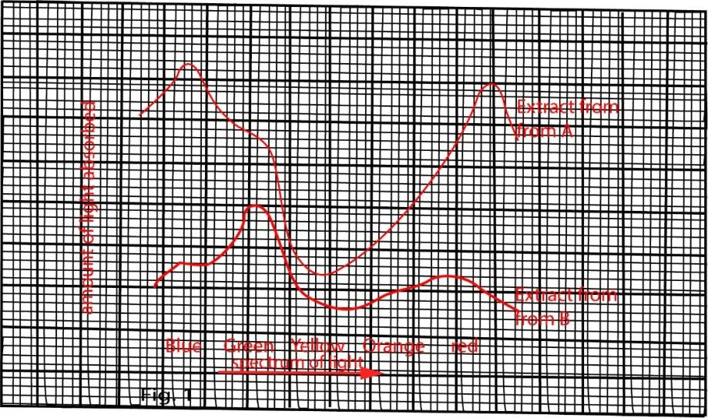
In another experiment, six identical shoot of pond weed were placed in separate test tube of pond water in which a dilute solution of sodium hydrogen carbonate had been added. Each test tube was exposed to light which had passed through different coloured filter. The light in all cases was from a 40 watt bulb, placed 40cm from each test tube. The time taken for 20 bubbles to leave the cut end of each shoot was recorded three times and average results were recorded in table 1
Table 1
Colour filter | Average time taken to release 20 bubbles in seconds | Number of bubbles released per minute
Violet | 58
Blue | 40
Blue-green | 62
Green | 132
Yellow | 96
Orange-red | 70

Use the information to answer the questions that follow
- Compare the light absorption by extracts from Group A and that of Group B across the light spectrum. (8marks)
Similarities
  - Both have two absorption peaks
  - Light absorption by extracts from both groups A and B is greater in blue, green and red light and least in yellow light across the spectrum.
Differences

Extract A | Extract B
Across the spectrum, light absorption by extract from group A is greater than that from group B | Across the spectrum, light absorption by extract from group B is lower than that from group A
Peak absorption at blue | Peak absorption at green
the order of absorption is blue > green > orange >> yellow | the order of absorption is green > blue > red > orange > yellow.

- Explain the light absorption across the light spectrum for each extract. (9marks)

Extract from group A
Chlorophyll molecules in extract from the group A are well formed because of the adequate amount of nutrients (including magnesium) and therefore capable of absorbing enough light energy for photosynthesis. Being a green molecule, chlorophyll absorbs most of the other colours of the spectrum but reflects green and yellow.

Extract from group B
Extract from group B has inadequate amount of magnesium so that chlorophyll molecules formed are incomplete. Such molecules are less efficient in absorbing light energy for photosynthesis. The photosynthetic pigment formed is yellowish and has a poor absorption capacity for the colour of the light spectrum compared with the green pigment of the extract from group A. however it absorbs other colours of the spectrum better than yellow which is reflected.
- How does a coloured filter affect light passing through it? (1mark) A color filter works by absorbing certain wavelengths of color and transmitting the other wavelengths. For example, a yellow color filter absorbs all colors except yellow, letting only yellow through, so the objects viewed appear to be yellow. If a blue light from a blue filter hits a red object, the blue color is absorbed and the object reflects no light, making it appear to be black.
- (i) Copy and complete Table 1, by calculating the number of bubbles released by each shoot per minute. (3marks)
1 minute = 60 second
For violet
58 seconds produce 20 bubles
Hence 60 seconds/1minute produce 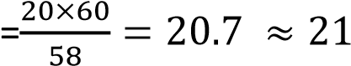
The other values in the table can be determined in the same way,
Colour of filter | Average time taken to release  20 bubble in seconds | Number of bubbles released per minute
Violet  Blue  Blue-green  Green  Yellow  Orange red | 58  40  62  132  96  70 | 21  30  19  9  13  17

  - Plot a graph to show the relationship between the colour of the filter and the rate at which bubbles are released. (6marks)

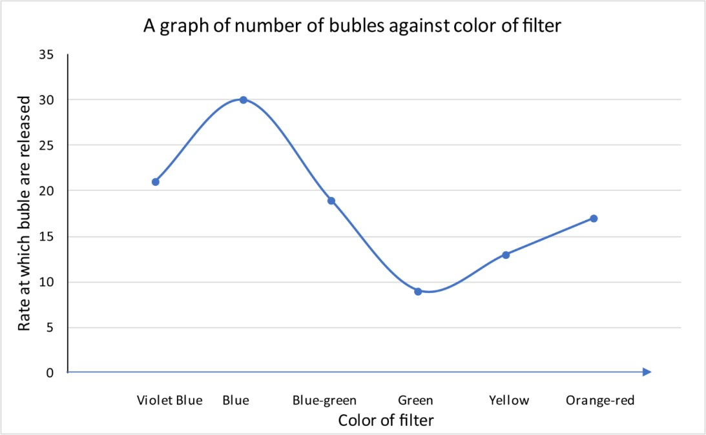
- (i) compare your graph with that in figure 1, and state the relationship between the two;
In both graphs, the absorption of light is higher in the violet-blue and orange ranges and minimum in the green-yellow-range of the light spectrum.

  - What conclusion can you draw from the relationship? (2marks)
    - Violet-blue and orange-red ranges of the spectrum favour the process being investigated better than the other colours.
    - Chlorophyll absorbs light well in the violet and orange red regions of the spectrum which energy is used in photosynthesis.
- State what would be observed if the distance between the bulb and the test tubes was gradually reduced. Explain your answer. (4marks)
The number of bubbles produced per minute would increase and then reach a maximum and become constant rate due to increased light intensity. A maximum rate is reached when other factor other than light intensity limit the reaction

- Explain why
    - the type of bulb and the distance of the bulb from the test tube were kept constant
(1mark) to maintain a constant temperature and light intensity reaching the test tube.
    - a dilute solution of sodium hydrogen carbonate was added to pond water in the test tubes. (2marks)
To produce carbon dioxide that is used by the plants during photosynthesis.
    - There were three measurements made on each shoot rather than a single one
(1mark) To minimize statistical errors
    - Measuring the rate of photosynthesis by counting bubbles in not accurate
(1marks)
- Some oxygen produced could have been used in respiration
62. In an experiment to determine the factors affecting photosynthesis, seedlings of a plant were divided into two groups and grown at a constant high light intensity (25 arbitrary units), another group grown at a constant low light intensity (3 arbitrary units). When the plants were mature, their apparent rates of photosynthesis in milligrams of oxygen released per unit leaf are per hour, were measured over a range of different light intensities Figure 1 shows the results of the experiment. In addition, some characteristics of the two groups of plants were recorded on table 1



0
20
40
60
80
100
0
5
10
15
20
25
30
plant previously grown at

high light intensity

plant previously grown at

low light intensity

Apparent rate of photosynthesis in mg

of oxygen per m
2

per hour


Light intensity (arbitrary)
)units)

Table 1
Groups of plants | Characteristics
Plants grown at high light intensity | Big, dark green leaves with short internodes
Plants grown at low light intensity | Small, pale yellow leaves with long internodes
- From the graph, state
  - differences in the effect of light intensity on the groups of plants (8marks)
Plants previously grown at low light intensity | Plants grown at high light intensity
Photosynthetic rate is generally lower | Photosynthetic rate is generally high
Photosynthetic rate reduces at high light intensities | Photosynthetic rate increases and  peaks at higher light intensities
Optimum light intensity for  photosynthesis is lower | Optimum light intensity for  photosynthesis is higher
Peak photosynthetic rate lower | Peak photosynthetic rate higher
Photosynthetic rate is higher at lower light intensities. | Photosynthetic rates are lower at low light intensities
Increase in photosynthetic rates with light intensities is gradual | Increase in photosynthetic rate with light intensities is rapid

  - similarities in the effect of light intensity on the two groups of plants. (3marks)

    - Increase in light intensities cause increase in photosynthetic rate at lower light intensities in both cases
    - In both there is optimum light intensity at which photosynthetic rates remain constant called the peak photosynthetic rate.
    - In both groups, photosynthetic rate is low at lowlight intensity
- Suggest explanation for the differences you have stated in (a) (i). (8marks)
Plants grown previously at high light intensity generally have high rate of photosynthesis
at high light intensities because are well adapted to trapping and utilization of light energy for photosynthesis than those previously grown at low light intensity, i.e.
  - They have more chloroplasts for trapping sunlight energy.
  - Have high stomata density to increase the rate of gaseous exchange and prevent overheating at higher light intensity
  - Has much carotenoid to prevent damage to chlorophyll from very bright light. Plants previously grown at low light intensity have high photosynthetic rate at low light intensities because
  - Its enzyme have low optimum temperature
  - Has thin leaves to maximize light penetration
  - Long internodes exposes each leave to light
  - Low stomata density reduces heat low to avoid over cooling.

- Explain the pattern of the curve for plants grown in low light intensity. (6marks)
  - Initially the of photosynthesis increase with temperature (0.5 -4 unit light intensity), because increase in light intensity increases the rate excitation of electrons from PSI and PSII leading to production of ATP and NADPH for the dark reaction.
  - The rate of photosynthesis then slows up because other factors other than light (such as amount of chlorophyll, temperature/carbon dioxide concentration) limit the rate.
  - The rate of photosynthesis then drops because at very high light intensity, high temperature denatures the photosynthetic enzymes.

- Explain the observed characteristics of the two groups of plants as indicated in table 1.
(9marls)
Plants previously grown at low light intensity have
    - Have pale leaves because they have low density of chlorophyll
    - Have small leaves are due to low rate of photosynthesis producing less nutrient to build structures
    - Long internodes to allow increase in length to search for light. Plants previously grown at high light intensity
    - Have dark leaves due to high density of chloroplast
    - Have broad leaves due to available nutrients from photosynthesis
    - Broad leaves to provide large surface area to trap light

- Suggest why:
    - Seedlings of the same plant were used in the experiment. (2marks) to minimize errors due to genetic composition
    - The rate of release of oxygen was used to measure the rate of photosynthesis.
(2marks) oxygen is easier to quantify.
- Name two factors that may limit the rate of photosynthesis of plants previously grown in high light intensity, if subjected to light intensity above 25 arbitrary units.
(2mark)
– temperature
    - Chlorophyll
    - Carbon dioxide concentration

63. (a) How does a bacteria cell differ from that of a higher plant? (5marks)
Bacterial cell | Plant cell
Independent single celled organism | Is the structural and function unit of plant
Prokaryotic cell | Eukaryotic cell
Cell wall made of murine | Cell wall made of cellulose
Has no membrane bound nucleus | The nucleus is double membrane
Respiration occurs in mesosome | Respiration occurs in mitochondria
DNA single strand | DNA double strand
Ribosome 70S | Ribosome 80S
Lack chlorophyll | Has chlorophyll
Lacks vacuole | Has permanent vacuole
Sexual reproduction by conjugation | Sexual reproduction by fusion of gametes
Small in size | Big in size

- Giving Examples, describe the different nutritional groups of bacteria. (5marks)
No. | Nutritional type | Source of energy | Source of carbon | Source of hydrogen | examples
1 | Photoautotrophs | Sunlight | CO₂ | H₂S | Green sulphurbacteria
2 | Photoautotrophs | sunlight | CO₂ | H₂O | cyanobacteria
3 | photoheterotroph | Light | Organic compounds | Organic compounds | Purple non sulpur bacteria
4 | Chemoautotrophs | Inorganic compounds such | CO₂ | H₂O | Nitrifying bacteria,
 |  | as NH₃, NO₂, H₂, H₂S |  |  | nirobacter
5 | heterotrophs | Organic compound | Organic compounds |  | Most bacteria
- Discus the importance of bacterial in nature. (10marks)

A. Harmful effects
- Bacteria are agents of disease of animals and plants such as syphilis, cholera, tetanus
- Bacteria cause milk and food deteriorate
- Denitrifying bacteria such as Thiobacillus lead to deterioration of soil fertility.

B. Useful effects
- Saprotrophic bacteria cause decay of waste materials and lead to formation of humus and recycling of minerals. E.g. Bacteria (Nitrosomonas and nitrobacter) convert organically combined nitrogen (e.g. protein) to nitrate which are absorbed by plants.
- Nitrogen fixing bacteria e.g. Azobacter fix nitrogen into the soil.
- Aerobic and anaerobic bacteria are useful in digestion of sewage into harmless substances. Methane gas given off is sometimes used for fuel.
- Mutualistic bacteria in ruminants’ assist ruminants to digest cellulose, and synthesis of vitamin K and B group.
- Some bacteria on the skin of humans enable it to obtain protection again inversion of pathogenic organism
- Bacteria and fungi are useful for making of cheese.
- Used for production of useful chemicals in genetic Engineering such as insulin

64. (a) Distinguish between a bacterium and a plant (6marks)

Differences between bacteria and plant cell
bacterium | Plant
Unicellular organism | Multicellular organism
Nuclear membrane absent | Nuclear membrane present in all cells
DNA is circular and lies free in the cytoplasm | DNA is linear and contained in a nucleus
Membrane bound organelles absent | Membrane bound organelles present
DNA is naked | DNA is associated with proteins to form chromosomes.
Ribosomes are smaller (70S | Ribosomes are larger (80S)
Ribosomes lie free in the cytoplasm | Ribosomes may be attached to endoplasmic reticulum
Mitochondria absent. Respiration carried out by mesosomes | Mitochondria are responsible for aerobic respiration
When present, cell wall is the noncellulose type, composed of amino sugars and muramic acid. | The cell wall is composed of cellulose
- Explain the ecological significance of different nutritional types of bacteria (07marks)

(i) Chemo-heterotrophic bacteria use chemical substance obtained externally as their source of food and energy. They are of vital ecological importance depending on their activities in the ecosystem as illustrated;
  - Saprophytic bacteria; these derive organic materials from dead decaying organic matter. Examples include, putrefying bacteria. These bacteria are the main organisms to decay. They decompose dead bodies of plants and animals and covert their complex compounds into simpler substances which are taken up by green plants for the synthesis of new complex organic compounds, in this way, these bacteria help in the cycling of matter which would otherwise have been lost from the ecosystem.
  - Symbiotic bacteria; several bacteria are found in nature in symbiotic relationship with man and other animals. Cellulose-producing bacteria in the gut of wood-eating ants offer the best example. In exchange for shelter provided by the ants, these bacteria help to produce cellulose enzyme that helps these organisms to utilize cellulose in their diet. As a result, they help in recycling of nutrients locked in the cellulose of wood. Also the bacterium, rhizobium, fixes nitrogen in a symbiotic association with roots of leguminous plants such as peas and beans. This increases the nitrate content of the soil and can be utilized by organisms in the ecosystem.
  - Parasitic bacteria; these are important in causing disease to organisms in the ecosystem. Examples include; cocci and bacilli. By causing disease, they may lead to death of some non-resistant organisms in the ecosystem leading to population regulation and reducing competition for resources in the ecosystem.
  - Chemo autotrophic bacteria are more commonly known as chemosynthetic bacteria. They use carbon dioxide as the source of carbon but obtain their energy from chemical reactions. Examples include nitrifying bacteria (nitrosomonas, nitrococcus and nitrobacter), iron bacteria, hydrogen bacteria etc. they enrich the soil with nitrogen through their oxidative reactions.
  - Photo autotrophic bacteria are also referred to as photosynthetic bacteria. They use sun light energy as their source of energy and carbon dioxide as the source of carbon. They are important in introducing oxygen to the atmosphere and also providing organic materials for heterotrophic micro-organisms in the environment.

- Explain how a leguminous plant and bacteria in nodules benefit from the relationship.
(07marks)
The roots of leguminous plants often have nodules in which are numerous rhizobium bacteria. The two organisms live together in mutualistic relations, i.e, both organisms benefit and none is harmed.
  - The leguminous plant provides water, shelter, protection and nutrients (organic and inorganic) to the bacteria.
  - The rhizobium bacteria have the ability of fixing nitrogen, in the form of nitrates into the soil from the atmosphere. The nitrates are absorbed and utilized by the leguminous plant.
65. (a) How are leaves modified to perform its function? Modification of leaves to their functions
- Flattened surface to reduce diffusion distance
- Shiny waxy cuticle to reduce water loss
- Mosaic arrangement to increase light absorption
- modified into tendrils to support weak climbing stems e.g. Gloriosa, peas
- Some leaves are modified into spine in order to reduce water loss. Spines also protect the plant from herbivorous animals
- Some leaves are modified into scale leaves (thin, membranous, dry colorless structures) for protection. E.g. onion outer leaves
- Phyllode : It is a green, expanded structure formed by the modification of petiole or rachis of leaf. Many xerophytes reduce the size of their leaves to minimize water loss. Such plant develop phyllodes to carry out photosynthesis e.g., Acacia, Melanoxylon and Parkinsonia.
- Some leaves are flesh to store water and food
- Some leaves develop vegetative bud for reproduction, e.g. bryophyllum
- In some rootless, aquatic plants, the submerged leaves are modified into root like structure to absorb water and mineral salts. Such modified leaves are called absorbing leaves. e.g., Utricularia.
- Some leaves are brightly colored to attract insect pollinator, e.g. Bougainville (xii) Some leaves are modified to trap insects.
(b) Describe the importance of leaves to the plants.
- Carry out photosynthesis with subsequent production of organic materials
- Carry out gaseous exchange through the stomata
- Transpiration takes place mainly through the leaves resulting in the cooling of plant and absorption of mineral salts and water
- Some leaves such as those of peas are modified by tendrils for support.
- Some leaves suck those bryophyllum are modified for storage
- Some leaves such as for bryophyllum are modified for vegetative reproduction
- Some leaves possess itching hairs, thorns, spikes and poisonous substances for protection of plant.
- Some leaves e.g. Venus fly trap are modified for capturing and extracting nitrogen from animals
- Some produce substances that kill parasites.

66. (a) Compare photosynthesis and aerobic respiration (9marks)

Similarities
- Both are energy converting processes.
- Both require mechanisms for exchange of carbon dioxide and oxygen.
- Both processes have a reaction pathway in which ATP is formed i.e. photo phosphorylation and oxidation phosphorylation in photosynthesis and respiration respectively.
- Bother processes involve enzyme-controlled reactions.
- Both require special organelles in eukaryotes, chloroplasts for photosynthesis and mitochondria for respiration.
- Both processes are affected by temperature.
Differences
Aerobic respiration | Photosynthesis
A catabolic process (involves breakdown of carbohydrates into simple of sugar) inorganic compounds. | An anabolic process which results in synthesis of carbohydrate molecules from simple inorganic compounds.
Energy is incorporated into ATP for immediate use | Energy is accumulated and stored in carbohydrates
Oxygen is used up | Oxygen is released
Carbon dioxide and water are released | Carbon dioxide and water are used up
Process occurs in decrease in dry mass | Results in increase in dry mass
Process occurs in mitochondria in eukaryotes | Process occurs in chloroplast in eukaryotes
Takes place continuously throughout life and is independent of chlorophyll and light | Occurs only in cells possessing chlorophyll and only in the presence of light.

- Explain the effect of low oxygen tension on
  - C3 plants (3marks)
Low oxygen tensions stimulate photosynthesis in C₃ plants due to reduced competition between oxygen and carbon dioxide for the active site of ribulose -1, 5biphosphate (RUBP) carboxylase enzyme.
  - C4 plants (2marks)
Low oxygen tensions have no effect on the rate of photosynthesis in C₄ plants because the active site of phosphoenol pyruvate (PEP) decarboxylases enzyme does not accept oxygen.

- Explain why c4 plants are more efficient in photosynthesis than C3 plants. (06marks)
  - In C4 plant PEP carboxylase fix CO₂ and delivers it to the enzyme RuBisCO at high concentration resulting in high rate of photosynthesis.
  - Photorespiration in C4 plants is negligible because PEP carboxylase does not accept oxygen
  - C4 plant are able to photosynthesize at high rates at high temperature because they do not experience photorespiration

TOPIC 3: Transport in Humans
Competency: The learner appreciates the mechanisms of transport of substances in the blood, and the immune system’s role in protecting the human body by analysing the processes and their role in the maintenance of human health, to prevent diseases in everyday life.
Contents
Transport in humans 3
The circulatory system in humans perform the following functions 3
Adaptation of the arteries 4
Adaptation of veins 4
The heart 5
Blood flow through the heart 5
Cardiac muscle 7
Beating of the heart 7
Control of heartbeat by the brain 8
Control of blood pressure 9
The effect of carbon dioxide concentration on the heartbeat rate 9
How the body detects and responds to high CO₂ 9
The blood 10
Functions of mammalian blood 10
Components of blood 10
Transport of oxygen 11
Adaptations of red blood cells to its function 12
Structure of hemoglobin 12
Oxygen dissociation curve 13
Transport of carbon dioxide 16
The responses of athletes versus non-athletes, and low land dwellers versus high land dwellers, to exercise 16
Low-land vs. high-land dwellers 18
Carbon monoxide poisoning 18
Sources of carbon monoxide poisoning 19
Ways of reducing carbon monoxide poisoning 19
How to manage carbon monoxide poisoning 19
Defense against Diseases 19
Antisepsis and asepsis 19
The immune system 19
Role of the immune system 20
Types of immunity 20
Natural/Nonspecific immunity 20
Adaptive immunity/acquired immunity 22
Antigen 22
T lymphocytes 22
The role of lymph nodes in prevention of diseases in animals 23
Active immunity 23
Passive immunity 24
Comparison of active and passive immunity 24
Ways/mechanism by which antibodies combat antigens 25
Vaccination 25
Types of vaccines 26
Benefits of vaccination 26
Vaccine safety and risks 26
The mechanism used in rapid test kits to detect infections 26
Blood groups, the ABO system 27
The Rhesus system 28
New-born haemolytic disease 28
Revision question transport in human 31
Revision question about defense against disease 49

Transport in humans
Transport is the movement of materials from one part of the body to another. Transport involves diffusion, and active transport at cellular level.

The circulatory system in humans perform the following functions
- Supplies metabolites and removes waste products from the cells at a faster rate than diffusion would do.
- It enables separation of materials transported; e.g. oxygenated blood is transported different vessels from those that transport deoxygenated blood.
- Avoids utilization of materials along the way.

The Human circulatory
The circulatory system consists of three independent systems that work together: the heart (cardiovascular), lungs (pulmonary), and arteries, veins, coronary and portal vessels (systemic). The system is responsible for the flow of blood, nutrients, oxygen and other gases, and as well as hormones to and from cells.
The figure below shows the main blood vessel in the human Circulatory system
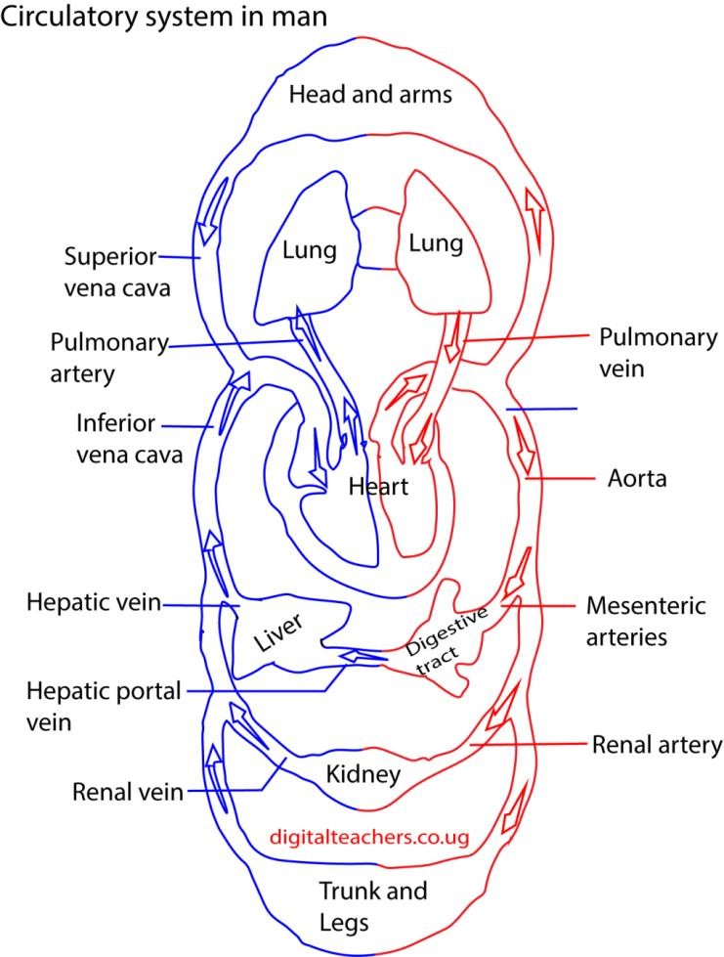

Arties and vein
Arteries transport blood at high pressure to the body while veins transport blood at low pressure from the body to the heart.
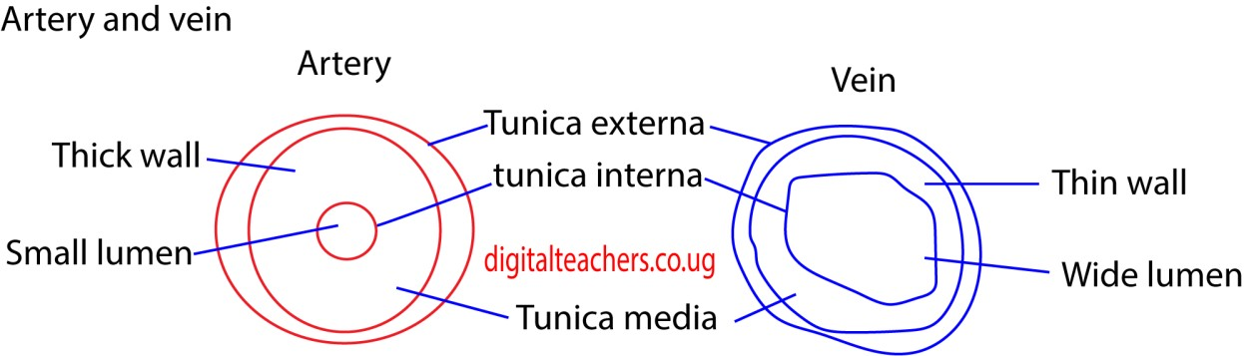

Adaptation of the arteries
- thick wall to accommodate high pressure
- have a narrow lumens to maintain high pressures
- some arteries like aorta valves to prevent back flow of blood.
- Deep seated in the body for protection
- Smooth endothelium to reduce resistance to blood

Adaptation of veins
- wide lumen to lower resistance to blood flow - valves allow blood tom flow in one direction

Differences between arteries and veins
 | Arteries | veins
1 | Thick wall | Thin walls
2. | Narrow lumen | Broad lumen
3. | Have no valves except pulmonary artery and aorta | Have valves
4. | Carry oxygenated blood except pulmonary artery | Carry deoxygenated blood except
5. | Pulse detectable | Pulse not detectable
6. | Empty at time of death | Get filled up at death.
Capillaries
Is where exchange believe blood and cell takes place

Adaptation of capillaries
- thin walls for fast diffusion
- form a dense network that reaches every cell of the body.

The heart
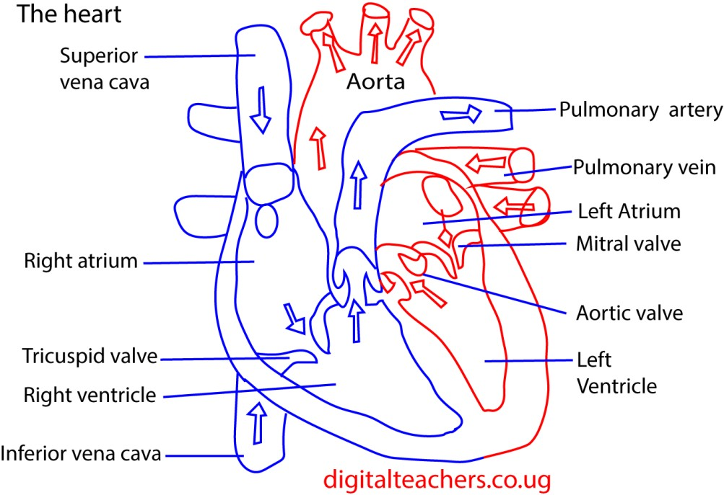
The heart pumps blood to and from the body

Blood flow through the heart
Blood returning via the venae cava enters the right atrium. The resulting pressure in this chamber forces open the flaps of the tricuspid valve. The result is that blood flows through the atrioventricular opening into the right ventricle.
When the atrium and ventricle are full of blood the atrium suddenly contracts, propelling the remaining blood into the ventricle. The contraction spreads from the right atrium over the rest of the heart. A trial systole is relatively weak but the ventricles, whose thick walls are particularly well endowed with muscles, contract more powerfully. As a result, blood is forced from the right the ventricle into the pulmonary artery.
The blood is prevented from flowing back into the atrium by the flaps of the atrio-ventricular opening. The atrio-ventricular valve is prevented from turning inside out by tough strands of connective tissue, the tendinous cord or “heart strings” which run from the underside of each flag to the wall of the ventricle
Once in the pulmonary artery, blood is prevented from flowing back into the ventricle by pocket like semilunar valves guarding the opening of pulmonary artery.
From the lungs oxygenated blood returns to the left atrium via the pulmonary veins. It is then conveyed to the left ventricle and so into the systemic arch which leads to the aorta. The flow of blood takes place in the atrioventricular valve consists of two flaps rather than three, for which reason. It is called the bicuspid valve. It is also known as the mitral valve because its two flaps are rather like a bishop’s miter.
Although systole starts at the right atrium, it quickly spreads to the left so that the whole heart appears to contract synchronously. The de-oxygenated blood is pumped from the right ventricle into the pulmonary artery at the same time as oxygenated blood is pumped from the left ventricle in the aortic arch.
Systole is followed by diastole during which the heart refills with blood again. The entire sequence of events is known as the cardiac cycle.
The graph below illustrates the pressure and volume changes that occur during mammalian cardiac cycle (dog). Pressure changes were measured in the left atrium, ventricle and the aorta. Volume changes were measured for both ventricles. The electrical activity in the heart wall (Electrocardiogram) and heart sound (Phonocardiogram) as recorded in human subject are also shown.
The graph below illustrates the pressure and volume changes that occur during mammalian cardiac cycle (dog).
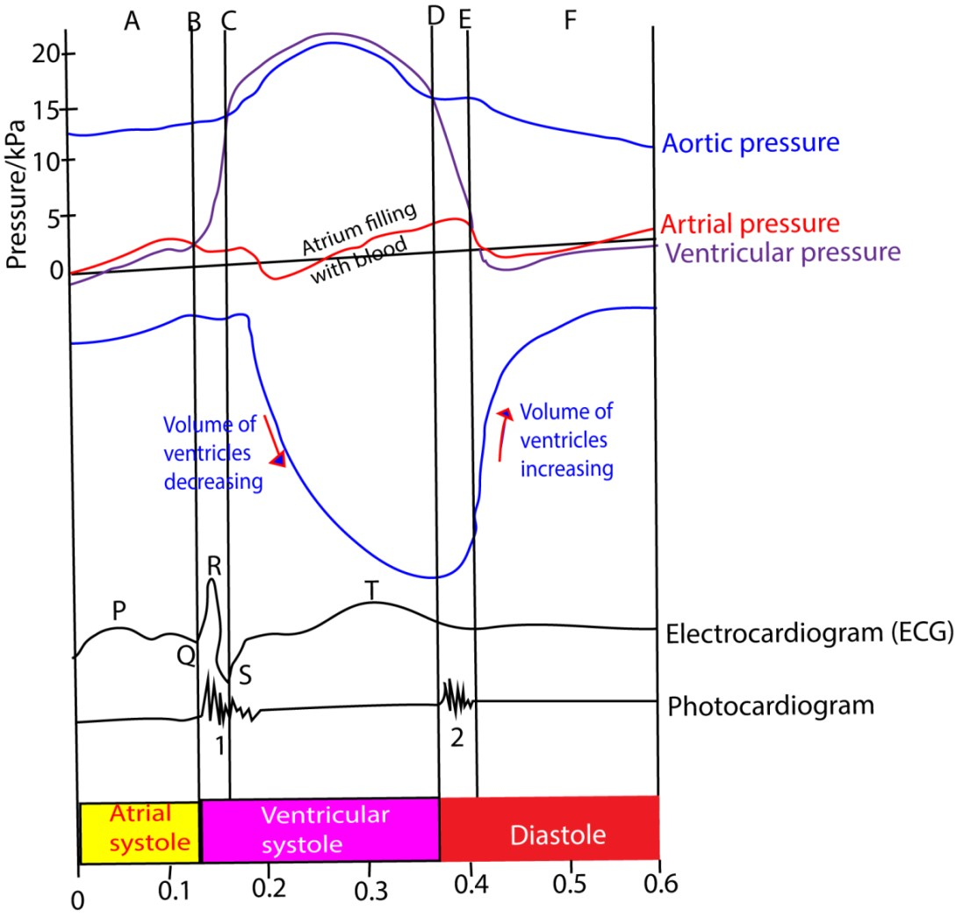

The actions at different points on the graph are described below
- - Atrium starts to contract: blood flows into ventricle
- - ventricle starts to contract: ventricular pressure exceeds atrial pressure; atrioventricular valve close
- - Ventricular pressure exceeds aortic pressure, forcing aortic valve to open; blood flows from the ventricle and ventricular volume falls
- - Ventricular pressure falls below aortic pressure; aortic valves close
- - Ventricular pressure falls below arterial pressure; blood flows from atrium to ventricle; ventricular volume raises rapidly.
- - Atrium continuing to fill with blood from pulmonary vein; atrial pressure exceeds ventricular pressure so blood flows from atrium to ventricle

Cardiac muscle
The most remarkable feature of the heart is the ability to contract rhythmically without fatigue. It owes this property to its muscle know as cardiac muscle. The muscle consists of a network of interconnected muscle fibres.
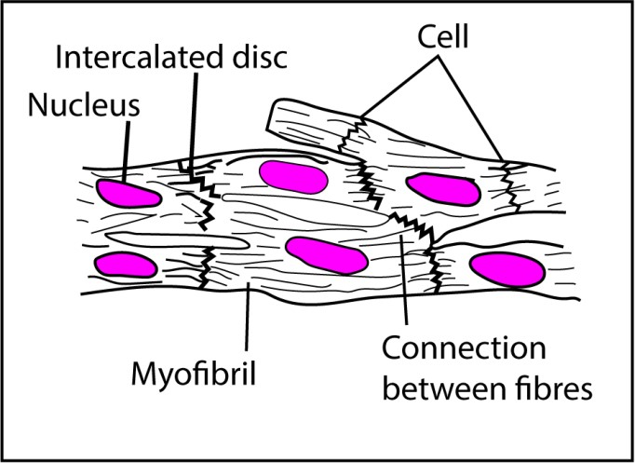
The fibres are divided up into uni-nucleated cells containing myofibrils. The interconnections (intercalated discs) between the fibers ensure a rapid and uniform spread of excitation throughout the walls of the heart which in turn ensure a uniform contraction.

Beating of the heart
Cardiac muscle is myogenic, that is, generate rhythmical contraction from within its muscle. The heart rhythm is initiated by specialized plexus (network) of fine cardiac muscle fibres embedded in the walls of the right atrium close to where the vena cava enters the heart, called sino atrial node (SAN) or the pacemaker. The contraction of the heart is preceded by a wave of electrical excitation from SAN and then spread over the heart atria. When the wave reaches the junction between the atria and ventricle, it excites another specialized group of modified cardiac muscle fibres called the atrio-ventricular node (AVN), Continuous with the AVN is a strand of modified cardiac muscles fibres called Bundle of Hiss. This runs down the inter-ventricular septum and fans out over the walls of the ventricle where it breaks up into a network of fibres called Purkinje tissue just beneath the endothelial lining.
When the AVN receives excitation from the atria, it sends impulses down the bundle of Hiss to purkinje tissue. The impulse then spread out to the cardiac muscle tissue in the walls of the ventricle making it to contract.
The role of AVN is to delay electrical impulse from the atria to the ventricle to allow atria contract before the ventricle.
The purkinje tissues ensure slow uniform spreading of excitation to the ventricle after the contraction of the atria.
The ventral view of heart showing the spread of electrical beating of the heart initiated by the pacemaker, the nerves simply serve to speed up or slow down the heart

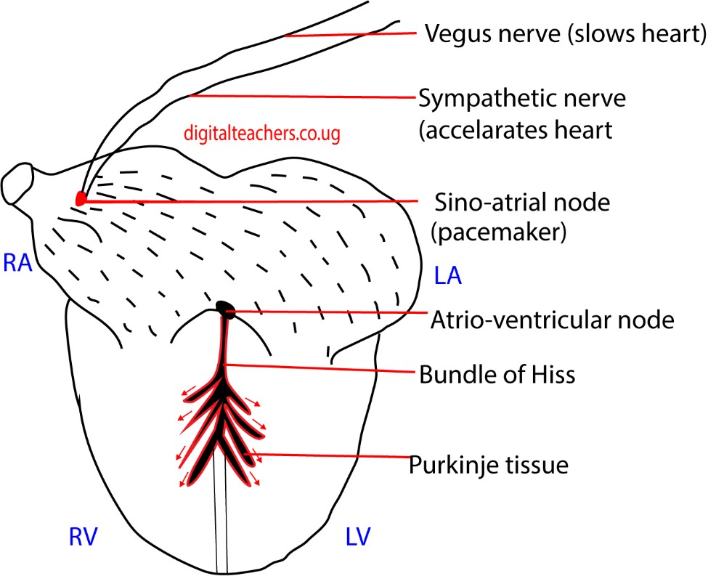

Control of heartbeat by the brain
The cardio vascular center in the medulla of the brain controls the rate of heartbeat. Depending on circumstance, the cardiovascular center sends impulse down the sympathetic nerve to the heart, increasing its rate of heart beat or down the Vegas nerves decreasing the rate of heartbeat.

Control of blood pressure
Blood pressure is controlled by
- the autonomic nervous system (ANS), which provides a short-term regulation by detecting changes in blood pressure and adjusting cardiac output and/ or blood vessel diameter
- the kidneys provide a long term regulation by managing blood volume with hormones.
i.e. antidiuretic hormone (ADH) increases reabsorption of water in case of low blood volume.

The effect of carbon dioxide concentration on the heartbeat rate
Increased carbon dioxide (CO₂) concentration in the blood directly causes an increase in heart rate because the body's cardiovascular and respiratory systems work together to maintain stable levels of CO₂ and oxygen. When CO₂ levels rise, the heart must work faster to circulate blood to the lungs, where the gas can be expelled.

How the body detects and responds to high CO₂
The body has a built-in regulatory system to respond to rising CO₂ levels.
- Chemoreceptors: Specialized cells called chemoreceptors, located in the aorta and carotid arteries, detect the increase in blood CO₂.
- Brain signals: These chemoreceptors send signals to the cardiovascular control center in the brain's medulla oblongata, which is responsible for regulating the heart and lungs.
- Increased heart rate: The medulla oblongata then sends impulses to the sinoatrial (SA) node of the heart via the sympathetic nervous system. The SA node is the heart's natural pacemaker.
- Release of noradrenaline: Neurons release the neurotransmitter noradrenaline, which binds to receptors on the SA node. This binding causes the SA node to fire impulses at a faster rate, thus increasing the heart rate.
- Increased ventilation: In addition to increasing heart rate, the medulla also increases the rate and depth of breathing to expel the excess CO₂ from the lungs.

Examples of this response
- During exercise: When you exercise, your muscles produce more CO₂. This triggers the chemoreceptors and causes your heart and breathing rates to increase to transport oxygen to the muscles and remove CO₂.
- Poorly ventilated spaces: When people are in a room with poor ventilation, CO₂ levels can rise. Studies have shown that a rise in indoor CO₂ concentration can lead to an increase in heart rate.
- 7.5% CO₂ inhalation: Research involving volunteers inhaling a high concentration of CO₂ showed an increase in heart rate and blood pressure, along with feelings of anxiety

The blood
Blood is a specialized tissue consisting of several types of cells suspended in fluid medium called plasma.

Functions of mammalian blood
- Transport of soluble organic compounds from the small intestine to various parts of the body.
- Transport of soluble excretory matters to organs of excretion.
- Transport of hormones from glands where they are formed to target organs.
- Distribution of heat in order to maintain the body temperature
- Defense against diseases, which may be obtained through blood clotting, phagocytosis and immunity.
- Maintenance of a right blood solute potential as a result of plasma proteins activity. (vii) Transportation of respiratory gases i.e., CO₂ &O₂

Components of blood
- Water:
This maintains blood pressure and volume. It’s where dissolved materials are transported around the body. Pressure is particularly important since the glomerulus require high pressure to form urine.
- Plasma proteins:
These include
  - Serum albumen; abundant to increase the viscosity of blood and binds with calcium. Calcium is important for the functioning of enzymes.
  - Serum globulin which include
    - α-globulin, which binds with and transports hormone thyroxine, lipids and fat-soluble vitamins; A, D, E, K.
    - β-globulin, binds and transport iron, cholesterol and fat soluble vitamins; A, D, E, K.
    - γ-globulin are antibodies produced by lymphocytes for immune response.
  - Prothrombin- a catalytic agent involved in blood clotting.
  - Fibrinogen- a protein involved in blood clotting.
  - Enzymes- that control rate of metabolic activities in blood.
  - Mineral salts: include Na⁺, K⁺, Ca²⁺, Mg²⁺, HPO₄²⁻,HCO₃⁻, Cl⁻, etc. they regulate osmotic pressure and pH level of blood. Ca2+ helps nervous transmission and blood clotting.
  - Dissolved products od digestion, excretory products, vitamins and hormones that are transported in the body 3.
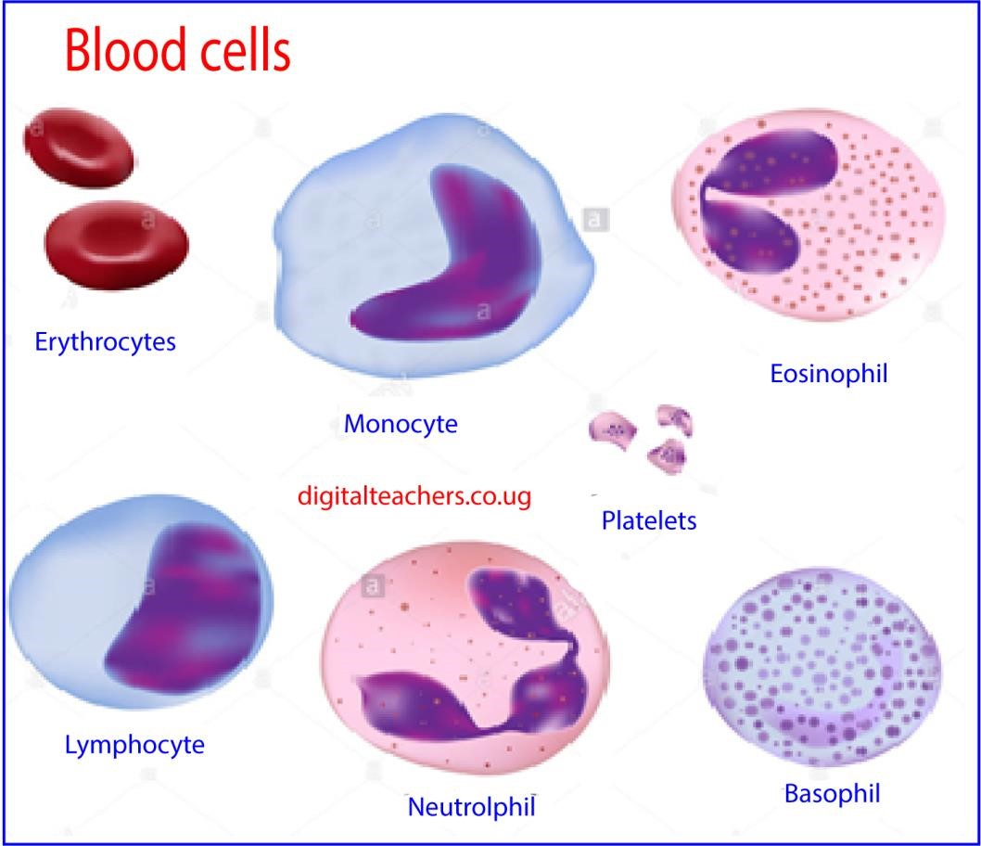

Transport of oxygen
Oxygen is transported by Erythrocytes or red blood cells. In embryo and infants, red blood cells are produced in the liver while in adults red blood cells are produced inn bone marrow.

Adaptations of red blood cells to its function
- They have a biconcave disc shape to increase the surface area for absorption of oxygen.
- They lack a nucleus to increase the amount of haemoglobin to be packed into the cell.
- They are small therefore able to squeeze between capillaries to deliver oxygen to the body cells.
- They have a thin membrane permitting efficient diffusion of gases (short distance for diffusion)
- They contain haemoglobin, which has a high affinity but reversibly combine with oxygen such that it combines with oxygen in the lungs and delivers it to the cells in the body.
- They do not carry out any metabolism so they do not utilize the oxygen being transported.

Structure of hemoglobin
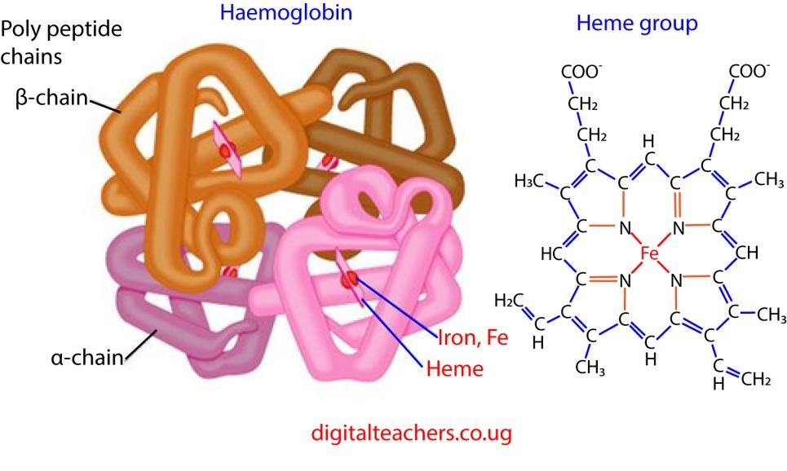
- Hemoglobin comprises four subunits, each having one polypeptide chain and one heme group.
- The polypeptide chains of adult hemoglobin are of two kinds, similar in length but differing in amino acid sequence.
- The two alpha chains each has 141 amino acid residues while the two beta chains each has 146 amino acid residues
- Heme, which accounts for only 4 percent of the weight of the molecule, is composed of a ring-like organic compound known as a porphyrin to which an iron in oxidation state II is attached.
- Oxygen binds reversibly to the ferrous iron atom in each heme group.
- The binding of oxygen to the heme group of one subunit has an effect of increasing
the affinity of a neighboring subunit (on the same molecule) for oxygen.

Functions of hemoglobin
- The main function of hemoglobin is to carry oxygen from the lungs to all the tissues of the body.
- Some of carbon dioxide is transported from tissues to lungs through hemoglobin. Although the majority of it is transported via plasma but still it carries some of CO₂ to lungs.
- Hemoglobin also acts as a buffer in blood. A buffer is a substance that resists change in pH. Blood has pH of 7.4 and it remains in the narrow range, because, if it changes, the life of the person may be endangered.
- Hemoglobin also transports of various drugs to their site of action.

Carriage of oxygen
Oxygen diffuses into the red blood cells across its plasma membrane and combines with the haemoglobin to form oxyhemoglobin. The attachment of oxygen does not involve chemical oxidation of iron which remains in Iron (II) state throughout the process. The union is a loose one, the oxygen molecule being attached to haemoglobin in the lungs and equally readily detached in the tissues.

Factors that affect the amount of oxygen carried in the blood Efficiency of haemoglobin as oxygen carrier
When one of the four polypeptide chains in haemoglobin molecule receives oxygen molecule in the lungs its structure is altered in such a way that the remaining three polypeptide chains accept oxygen readily. In the tissue the reverse occur: when one of the polypeptide chains loses its oxygen molecule and this causes the others to give up their oxygen more readily. In other words, haemoglobin takes up oxygen more rapidly if it already possesses one or more oxygen molecules, and releases it more rapidly if it has already released one or more oxygen molecules.

Oxygen dissociation curve
The ability of blood to transport enough oxygen to meet the needs of the body is largely attributed to the affinity of haemoglobin for oxygen.
This can determined by exposing a sample of blood to different partial pressures of oxygen (concentration of oxygen in air), and then determining the percentage saturation of blood with oxygen in each case.
A plot of percentage saturation of haemoglobin with oxygen against partial pressure of oxygen gives an oxygen dissociation curve below
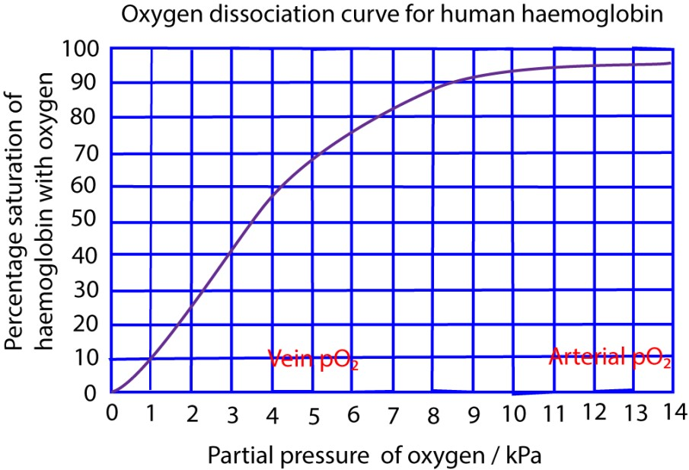
Oxygen dissociation curve is S-shaped (sigmoid) showing that it is very appropriate for a blood pigment. Over the steeply rising part of the curve, a small increase in the partial pressure of oxygen achieves a relatively high percentage saturation of blood.
The flat part of the curve at the top corresponds to the situation in the lungs: over this range a high saturation is maintained even if the partial pressure of oxygen in the alveoli falls.
The oxygen dissociation curve favors the loading oxygen in the lungs and offloads of oxygen the tissue.

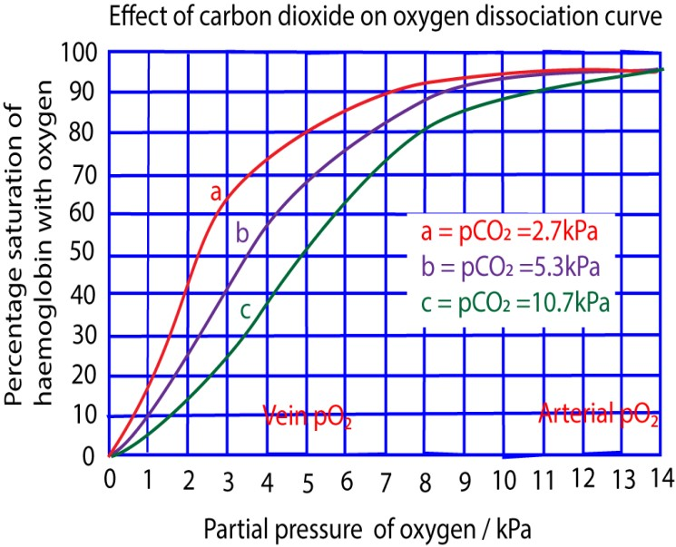
The graph above shows that a high concentration of carbon dioxide shifts the curve to the right. i.e. it lowers the affinity of haemoglobin for oxygen. The release of oxygen is therefore favored in the tissue where the partial pressure of carbon dioxide tends naturally to be high as result of its continual release from respiring cells. The oxygen uptake occurs in the lungs where the partial pressure of carbon dioxide is low.
In summary the affinity of haemoglobin for oxygen is reduced by
- Low oxygen concentration.
- High carbon dioxide concentration
- High body temperature
- Low PH
High carbon dioxide concentration (or low PH) has the effect of establishing deoxyhaemoglobin. This favors the unloading of hemoglobin hence reducing its affinity for oxygen.
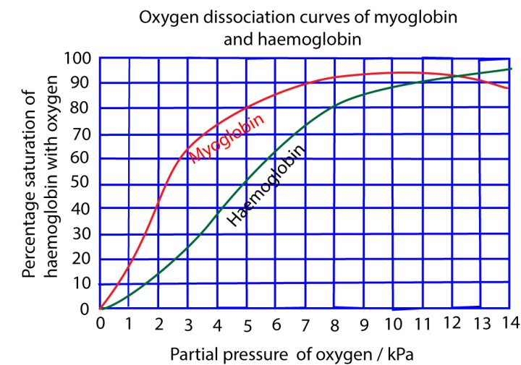
The oxygen dissociation curve of myoglobin lies at the left of that of hemoglobin because myoglobin has a high affinity for oxygen. Myoglobin is found in muscles; it picks oxygen from hemoglobin and stores it in order to be used when the partial of oxygen falls to a very low level as in severe muscle exertion.
Similarly, the hemoglobin of animals like lungworm, which burrow in oxygen-deficient mud, has higher affinity for oxygen than hemoglobin.
Location of the oxygen dissociation curve of an organism to the left of another usually indicates higher affinity for oxygen by its haemoglobin. Thus, the mountain gorilla has a high affinity for oxygen than many other animals. This allows its haemoglobin to get saturated at low oxygen tension. This enables it to survive in condition of low oxygen partial pressure at high altitudes
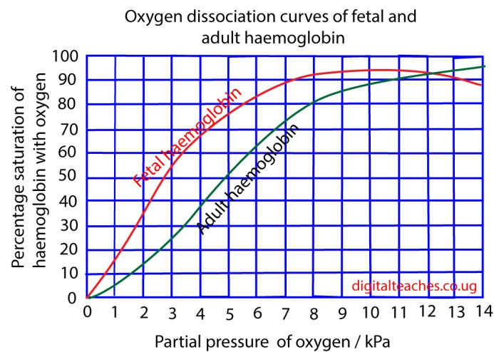
The oxygen dissociation curve of fetal hemoglobin lies at the left of that of hemoglobin; this this because fetal hemoglobin has a high affinity for oxygen than adult hemoglobin this enable fetal hemoglobin to pick oxygen from the mother’s blood.

Transport of carbon dioxide
CO₂ react with water to produce carbonic acid, H₂CO₃. In the red blood cells the reaction is catalyzed by carbonic anhydrase.
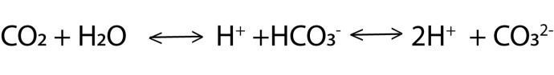
Carbonic acid dissociates into hydrogen ions. Hydrogen ions combine with haemoglobin to form haemoglobinic acid while HCO₃⁻ diffuses and transported in blood to the lungs.
The electroneutrality in the red blood cells is maintained by an inward movement of chloride ions from the plasma so- called chloride shift.
In the lungs, hydrogen ions combine with hydrogen carbonate ions to give CO₂ which is lost to atmosphere.

The responses of athletes versus non-athletes, and low land dwellers versus high land dwellers, to exercise
The responses to exercise in athletes versus non-athletes, and low-land versus high-land dwellers, are primarily driven by physiological adaptations from training and environmental conditions. Athletes and high-altitude natives develop more efficient systems for oxygen delivery and use, though their specific adaptations and baseline metrics differ.

Athletes vs. non-athletes
Physiological factor | Athletes (trained) | Non-athletes (untrained)
Cardiovascular efficiency | Higher. Athletes experience greater stroke volume, the amount of blood pumped per heartbeat. Their heart rate is therefore lower at rest and during submaximal exercise to achieve the same cardiac output. The heart muscle itself becomes stronger and the ventricle walls thicken, a condition known as "athlete's heart". | Lower. Untrained individuals have a lower stroke volume and a higher resting heart rate. Their hearts are smaller and less efficient at pumping blood.
Physiological factor | Athletes (trained) | Non-athletes (untrained)
Oxygen uptake | Higher. Athletes have a higher maximal oxygen consumption rate due to enhanced oxygen delivery and extraction. This is a key indicator of cardiorespiratory fitness. | Lower. Maximal oxygen uptake is lower, indicating a less efficient oxygen transport system.
Musculoskeletal adaptations | More developed. Athletes have stronger, more efficient muscles with a higher density of capillaries, allowing for better nutrient and oxygen delivery. They also have more mitochondria, which increases the muscle's oxidative capacity. | Less developed. Muscle  tissue is less efficient, with fewer capillaries and mitochondria. There is a higher percentage of body fat relative to lean muscle mass.
Recovery | Faster. After exercise, heart and breathing rates return to baseline values more quickly. Athletes also have higher stores of muscle glycogen, which replenish more efficiently after depletion. | Slower. Physiological parameters take longer to return to resting levels.
Metabolic efficiency | Higher. Trained individuals burn a higher proportion of fat during submaximal exercise, conserving glycogen for more intense efforts. | Lower. Untrained individuals primarily use carbohydrates for fuel during submaximal exercise.

Low-land vs. high-land dwellers
The primary difference between these populations is their long-term adaptation to hypoxia (lower oxygen availability) at high altitudes.
Physiological factor | High-altitude natives | Low-land dwellers (acclimatizing)
Maximal oxygen uptake | Higher than low-landers who have just arrived at altitude. Their bodies are genetically and developmentally adapted to maximize oxygen use in a lowoxygen environment. | Decreased upon acute exposure due to lower partial pressure of oxygen. While acclimatization improves performance.
Physiological factor | High-altitude natives | Low-land dwellers (acclimatizing)
Red blood cell count | Higher. Native high-land dwellers have higher concentrations of hemoglobin and total hemoglobin mass to increase oxygen-carrying capacity. | Initially lower. Upon arriving at altitude, the body gradually increases red blood cell production, stimulated by the hormone erythropoietin (EPO), but this process takes weeks to show significant effects.
Cardiovascular response | More efficient. High-land natives have a higher cardiovascular efficiency when exercising in their native environment. | Stressful. Acclimating individuals experience an increased heart rate and breathing rate at rest and during submaximal exercise to compensate for low oxygen levels.
Lactic acid buffering | Enhanced. Due to metabolic adaptations from generations of altitude exposure, high-land natives are more efficient at managing and buffering the build-up of lactic acid during intense exercise. | Less efficient. At high altitude, a lowlander's body relies more on carbohydrate metabolism, leading to faster lactic acid accumulation and fatigue.
Exercise capacity | Higher. They have a greater overall physical work capacity and endurance in hypoxic conditions compared to acclimatized low-landers. | Reduced. Initially, exercise feels more taxing and performance is significantly reduced. Exercise capacity improves with acclimatization but remains lower than at sea level.

Carbon monoxide poisoning
Carbon monoxide combines more readily with hemoglobin than oxygen. This prevent hemoglobin to combine with oxygen, thus carbon monoxide is powerful respiratory poison.

Sources of carbon monoxide poisoning
- Incomplete combustion of charcoal on sigiri/charcoal stove
- Burning rubbish
- Fireplaces
- Generators
- Tobacco smoke
- Wild/bush fires

Ways of reducing carbon monoxide poisoning
- Keeping burning charcoal stove outside the house
- Proper ventilation

How to manage carbon monoxide poisoning
- Remove the person from source of poisoning to a well-ventilated area.
- Keep the person still. Limit their activity to decrease their body's demand for oxygen
- Take the patient to the hospital facility

Defense against Diseases
Every animal is equipped with a complex system of defense mechanism which are designed it to withstand attacks by pathogens (bacteria, fungi and viruses) and to remove foreign materials form its system.

Antisepsis and asepsis
These artificial devises and technics aimed at elimination or prevention of entry of pathogens into the body.
- Sterilization by heat.
- Use of solutions called antiseptics that kill microorganism.
- Aseptic techniques which are aimed at eliminating germs from the environment altogether such as wearing sterilized clothes in the hospital theatre, keeping the theatre clean and leaning with disinfectants and detergents.

The immune system
This deals with microorganism that gain entry into the body. Immunity has been defined as by Sir MacFarlane Burnet as “the capacity of the body to recognize the intrusion of material foreign to the body and to mobilize cells and cell products to help remove that particular sort of foreign material with greater speed and efficiency.
The simplest component of the immune systems are the cell which engulf and digest foreign materials in blood and tissues in the same way as amoeba engulfs and digests its food by phagocytosis.

Role of the immune system
- Keeps invaders (like germs) from entering the body.
- Identifies and tags pathogens in the body
- Destroys pathogens by engulfing them or by use of antibodies.
- Store memory cells that produce an enhanced response to repeated infection by the same type of microorganism.
- Removes dead, faulty and cancer cells

Types of immunity

Natural/Nonspecific immunity
Nonspecific immunity, also known as innate immunity, is the body's first line of defense against pathogens and other foreign invaders. It provides a rapid, general response to a wide range of threats, distinguishing between "self" and "non-self" without needing prior exposure to the specific pathogen. Unlike specific (adaptive) immunity, innate immunity has no memory and reacts the same way to every encounter. Components of nonspecific immunity
The innate immune system includes several layers of defense, which can be categorized into three main types.

Physical and mechanical barriers
These are the body's initial line of defense, preventing pathogens from entering in the first place.
- Skin: The skin is a tough, waterproof barrier with a layer of dead cells that most microorganisms cannot penetrate. It is also covered in harmless microorganisms that compete with pathogens.
- Mucous membranes: These membranes line the respiratory, gastrointestinal, and urogenital tracts. They trap pathogens in a sticky substance known as mucus.
- Cilia: These are tiny, hair-like structures found in the respiratory tract that sweep mucus containing trapped pathogens towards the throat to be expelled.
- Reflexes: Actions such as coughing, sneezing, vomiting, and urination help to expel pathogens from the body.

Chemical barriers
These are fluids and substances that can kill or inhibit the growth of pathogens.
(v) Gastric acid: The stomach's low pH (high acidity) destroys most pathogens that are ingested.
- Tears and saliva: These fluids contain enzymes, such as lysozyme, which break down bacterial cell walls.
- Antimicrobial proteins: Secretions like sweat, sebum, and defensins can kill bacteria and other microbes on the skin's surface.
- Complement system: This is a group of proteins in the blood that can be activated to destroy foreign cells by punching holes in their membranes, a process called cell lysis.

Cellular defenses
If pathogens overcome the first two lines of defense, a variety of immune cells are deployed to attack and eliminate them.
- Phagocytes: These "eating cells" patrol the body and engulf foreign particles, dead cells, and invading microbes. Key phagocytes include:
- Macrophages: Large phagocytes that can leave the bloodstream to hunt pathogens in tissues.
- Neutrophils: Abundant phagocytes that are often the first responders to an infection site.
- Dendritic cells: Found in tissues exposed to the environment, they can engulf pathogens and also help activate the specific immune system.
- Natural killer (NK) cells: These cells can identify and destroy compromised host cells, such as those infected by a virus or that have turned cancerous, by recognizing abnormalities on their surface.
- Basophils and eosinophils: These cells release inflammatory mediators and are involved in fighting parasites and allergic responses.

General immune responses
- Inflammation: A localized response to tissue injury or infection. It involves swelling, heat, redness, and pain caused by the dilation of blood vessels. This process brings more immune cells to the affected area to fight the infection and initiate healing.
- Fever: A systemic response where the body's temperature is raised, which can inhibit the growth of some microbes and increase the metabolic rate of the body's cells to speed up repair.

Adaptive immunity/acquired immunity
This is different from natural immunity in the following ways.
- It is specific, that is, different types of cells responsible for it can distinguish between different types of microorganism.
- It has a memory, which enables its cells to produce an enhanced response to repeated infection by the same type of microorganism.
- It is brought about by lymphocytes because they are abundant in the lymphatic response, particularly lymph nodes.
There are two types of lymphocytes in blood and lymph: B lymphocytes and T-lymphocytes also called B-cell and T cells respectively for short)

Antigen
It is any substance that initiates an adaptive immune response. It may be a pathogen, its toxic product, or various non-harmful molecules and cells such as pollen and ampicillin.

B lymphocytes
The B-lymphocytes originate in the bone marrow. When a B lymphocyte encounters an antigen it produces antibody a specific protein molecule called immunoglobulin. The antibody combines with antigen and helps to eliminate it from the body. What makes B lymphocytes so remarkable is that they can produce highly specific antibodies against a vast number of different types of antigen.

T lymphocytes
These look exactly like B lymphocytes but they do not produce antibodies. The T lymphocytes also originate in the bone marrow but they have to pass through the thymus gland during their maturation. They are responsible for what is called cell-mediated immunity. T lymphocytes are more varied in their action than B lymphocytes, they have to make contact with their matching antigen to work. They have special receptors on their surface which enable them to recognize the correct antigen.
- T helper cells help other cells in the immune system. For example, they stimulate B lymphocyte to divide into antibody producing cells. If these helper cells are not present, the B lymphocytes cannot go into action. They also enhance the action of phagocytes. It is the T helper cells which are invaded by HIV.

- T suppressor cells suppress other cells in immune system. They have opposite effect of T-helper cells on B lymphocytes and phagocytes. They act as brakes in immune system, dampening it down and preventing from over reacting.

- T killer cells destroy cells infected with viruses before the viruses have time to proliferate. They also attack cells from other individuals if they get into the body and in doing so they cause the rejection problems associated with skin grafts and transplant surgery. T killer cells are regulated in the same way as B cells by the T helper and T suppressor.

Together, the T helper and T suppressor cells regulate and control the production of antibodies by the B cells and enhance or suppress the action of phagocytes. T cells also secrete short-lived messenger proteins called lymphokines which activate or suppress every aspect of the immune response. One of their functions is to stimulate macrophages to engulf other cells much more readily. This enables the macrophages to attack bacteria which invade the immune system and fight fungal infection and tumors.

One group of lymphokines are called interferons. These are effective against a wide range of viruses and they work by inhibiting the protein-making machinery of the infected cells so that viruses cannot proliferate. They also stimulate changes in infected cells which makes them resistant to the viruses.

The role of lymph nodes in prevention of diseases in animals
The lymph nodes monitor and cleanse the lymph flowing into them of pathogens, and store lymphocytes and other immune system cells that attack and destroy harmful substances like bacteria

Passive and active immunity
Passive immunity is the temporary protection from a disease by receiving pre-formed antibodies from an external source. In contrast, active immunity is long-lasting protection that results when your own immune system creates antibodies after exposure to a pathogen.

Both types of immunity can be acquired either naturally or artificially.

Active immunity
This type of immunity develops when your immune system encounters a pathogen or vaccine and is triggered to produce its own antibodies and memory cells. It is a slow process that takes time to build up, but it provides long-term protection, and sometimes even lifelong immunity.

How active immunity is acquired:
- Natural exposure: When you get an infection, like the chickenpox, your body produces specific antibodies and creates memory cells that recognize and fight the virus in the future.
- Vaccination: A vaccine introduces a killed or weakened form of a pathogen (or a specific component, such as an antigen) to trigger an immune response without causing the disease.
The body then produces memory cells to remember how to fight the real pathogen later.

Passive immunity
This type of immunity is the direct transfer of antibodies from one individual to another, offering immediate but short-lived protection. Because the body doesn't produce its own memory cells, the immunity fades once the transferred antibodies are degraded.
How passive immunity acquired:
- Natural transfer: A mother passes antibodies to her baby across the placenta during pregnancy and through breast milk, providing the infant with temporary protection. This is especially crucial in the first few months of life, before the baby's immune system is fully developed.
- Artificial transfer: Antibodies are transferred via blood products, such as an injection of immune globulin or antivenom. This is typically done when immediate protection is needed, for example, after potential exposure to rabies or tetanus.

Comparison of active and passive immunity
Characteristic | Active Immunity | Passive Immunity
Source of Antibodies | Produced by your own immune system. | Transferred from an external source, such as a mother or another person.
Response Time | Slower; takes days or weeks to develop after initial exposure. | Immediate; protection is available as soon as antibodies are transferred.
Duration of Protection | Long-lasting, often for years or a lifetime. | Short-lived, typically lasting only a few weeks to months.
Immune Memory | Creates immunological memory, so the body can respond quickly to future infections. | No memory cells are generated, so there is no lasting immune memory.
Method of Acquisition | Natural infection or vaccination. | Maternal antibodies (placenta, breast milk) or injections (immune globulin).
Clinical Use | Routine vaccination for long-term protection. | Emergency treatment for immediate, rapid defense, or for immunocompromised individuals.

Ways/mechanism by which antibodies combat antigens
- Neutralization: Antibodies bind directly to a pathogen or toxin, blocking it from interacting with host cells or neutralizing its harmful effects. For example, they can block viral proteins needed to enter a cell, rendering the virus unable to infect.
- Opsonization: Antibodies act as "tags" or "handles" on the surface of pathogens. This coating, or opsonization, makes it easier for phagocytic cells like macrophages and neutrophils to recognize, bind to, and engulf the pathogen for destruction.
- Complement Activation: When antibodies bind to a pathogen, they can trigger the complement system. This is a cascade of proteins that can lead to the lysis (bursting) of the microbial cell or further attract immune cells to the site of infection.
- Agglutination: Antibodies link multiple pathogens together, forming large clumps that are easier for phagocytes to clear from the body.
- Precipitation: Antibodies cause soluble antigens to clump together and fall out of solution, making them easier targets for phagocytosis.

Vaccination
Vaccination is the process of administering a vaccine to produce active acquired immunity against an infectious or malignant disease. Vaccines use a safe, modified version of a diseasecausing germ or its components to train the immune system to recognize and fight off that specific threat, protecting an individual from future infection without having to get the illness. How vaccines work
A vaccine works by harnessing the body's adaptive immune system, which has a memory for pathogens it has encountered before.
- Antigen introduction: The vaccine introduces an antigen—a key feature of the diseasecausing germ (e.g., a weakened or killed microbe, a fragment of its protein, or genetic material that codes for it).
- Immune response: The immune system recognizes the antigen as foreign and launches a response. It produces specialized cells (T-lymphocytes) and antibodies to fight it.
- Immune memory: The immune system remembers the germ. If the body is exposed to the real pathogen later, the memory cells and antibodies can quickly mount a defense, preventing illness.

Types of vaccines
Vaccines come in several types, each using a different method to stimulate an immune response. These include live-attenuated (weakened live germ, like MMR), inactivated (killed germ, like polio), subunit (parts of the germ, like HPV), toxoid (weakened toxin, like tetanus), mRNA (genetic material instructing cells to make a germ protein), and viral vector (harmless virus delivering genetic material for a germ protein) vaccines.

Benefits of vaccination
Vaccination provides several benefits, including protecting the vaccinated individual by preparing their immune system, contributing to community immunity by making disease spread more difficult, saving millions of lives annually from preventable diseases, and even eradicating diseases like smallpox.

Vaccine safety and risks
Vaccines are subject to rigorous safety testing before and after approval. While most side effects are minor and temporary, serious side effects are rare, and the protective benefits of vaccination generally outweigh the risks.

Problems arising from immune system
- Allergy: this is a group of unpleasant symptoms which result from an excessive immune responsible or hypersensitivity. These symptoms include bouts of sneezing, running nose, itchy eyes, fever and so on due to release of histamine. Allergies can be induced by a variety of agents/allergens such as grass pollen, cut fur, fungal spore, certain drugs and food, or as a result of an insect bite

- Rejection of transplanted tissue.

Chemotherapy and antibiotics
Chemotherapy is the use of chemical substances, natural or synthetic, that kill or prevent the production of microorganisms in the body. The term is now extended to include the inhibition of dividing malignant cell in cancer. The chemical substances are called chemotherapeutic agents. Some of these substances such as penicillin are secreted by microorganism and are selectively toxic to other microorganism in which case they are called antibiotics.

The mechanism used in rapid test kits to detect infections
Rapid test kits typically use a technology called a lateral flow immunoassay (LFIA) to detect infections. This technology is a paper-based diagnostic platform that can confirm the presence of a specific target molecule, known as an analyte, within a liquid sample. For infectious disease testing, the analyte is most often an antigen (a unique protein from a virus or bacterium) or, in some cases, the antibodies the body has produced in response to an infection.
The entire process relies on the principle of antigen-antibody binding, where highly specific antibodies are used to capture the target analyte.

Blood groups, the ABO system
The entire human population can be divided into four groups on the on the basis of the reaction between the blood group of different individuals when mixed together. These groups are called A, B, AB and O and are known as collectively as the ABO system. The capital letter stands for different types of glycoprotein present on the surface of person’s red blood cells. These glycoproteins are antigen, similar to those found on the surface of bacteria. We all make antibodies against foreign antigens, but not of course against those on our own red blood cell.
The antibodies are called anti-A and anti-B. if an individual has a particular antigen on the red cells, the corresponding antibody is not present in plasma. Thus a person belonging to blood group A has red cells with antigens A on them; the plasma does not contain anti-A antibody; but it does contain Anti B antibodies. A person belonging to blood group B, has B antigens on the red cells and plasma contains anti-A antibody only. In blood of blood group AB, the red cells
carry both antigen A and B and neither antibodies are present in plasma. Group O blood has neither antigen but both antibodies. When blood of different kind, say, A and B mixed. They agglutinate or form chimps which may block the recipients blood vessel. For instance, if blood of group A is given to a patient of blood group B, the anti-A antibodies in the patient’s blood will cause agglutination of the donors’ red cells because they carry the A-antigen. It does not matter that the donor’s antibodies (anti B) are incompatible with the recipient’s antigen B because the recipient receives relatively little blood and the dilution effect minimizes agglutination. The table below summarizes what happens when blood of different groups are mixed.


+

agglutination

-
No agglutination

Capital letter
-

antigen

Small letter
-

antibody

Oab

Ab

B
a

AB

Oab

-

-

-

-

Ab

+

-

+

-

Ba

+

+

-

-

AB

+

+

+

-

A universal donor (group O) can give blood to a recipient of any blood group without causing agglutination.
A universal recipient (group AB) receives blood from any donor of any group without agglutination. In practice blood transfusion are normally carried out using blood from the same group as the of the recipient. The group to which sample of blood belong is determined by a compatibility test.

The Rhesus system
In addition to the ABO system, there are many other antigens on human red blood cells. One of these is the Rhesus antigen, so called because it was first identified by injecting rabbits with red blood cells obtained from the rhesus monkey. The majority of people possess red blood cells with the Rhesus positive antigen present, and they are known as Rhesus positive (Rh⁺). The remainder lack the rhesus antigen and are called rhesus negative (Rh⁻).

New-born haemolytic disease
Hemolytic disease of the newborn (HDN), also known as erythroblastosis fetalis, is a blood disorder that occurs when there is an incompatibility between the blood types of a mother and her unborn baby. This incompatibility triggers the mother's immune system to produce antibodies that cross the placenta and attack the baby's red blood cells, causing them to break down.
Though there are other causes, the most common forms of HDN involve incompatibility in the Rh and ABO blood group systems.
Causes

(i) Rh incompatibility
This is the most well-known and severe type of HDN, and it typically affects a second or later pregnancy. It occurs when:
- An Rh-negative mother carries an Rh-positive baby. The Rh-positive factor is inherited from the father.
- During pregnancy or delivery, a small amount of the baby's Rh-positive blood enters the mother's bloodstream.
- The mother's immune system recognizes the Rh-positive cells as foreign and creates antibodies to destroy them. This is called sensitization.
- This first pregnancy is usually unaffected, as the sensitization process takes time. However, in subsequent pregnancies with an Rh-positive fetus, the mother's memory antibodies can cross the placenta and attack the baby's red blood cells.

(ii) ABO incompatibility
This type of HDN is generally much milder than Rh incompatibility and can occur in a first pregnancy.
- It typically happens when a mother with blood type O carries a baby with blood type A or B.
- Unlike Rh antibodies, which must be created through exposure, women with blood type O already have natural anti-A and anti-B antibodies. These antibodies can cross the placenta and target the baby's red blood cells.

Effects on the newborn
The consequences of HDN can range from mild to severe.
- Anemia: The destruction of red blood cells (hemolysis) leads to a low red blood cell count, making it difficult for the baby's blood to carry enough oxygen.
- Hyperbilirubinemia and jaundice: As the baby's red blood cells break down, they release bilirubin, a yellow pigment. While the placenta clears some of this during pregnancy, after birth the baby's immature liver may be overwhelmed. This leads to a buildup of bilirubin (hyperbilirubinemia), causing the skin and eyes to appear yellow (jaundice).
- Enlarged liver and spleen: The baby's body attempts to compensate for the anemia by producing more red blood cells, which causes the liver and spleen to enlarge.
- Kernicterus: In severe, untreated cases of hyperbilirubinemia, excessive bilirubin can spill over into the brain, causing permanent brain damage, hearing loss, and cerebral palsy.
- Hydrops fetalis: In the most severe cases of anemia, the baby's organs begin to fail, causing large amounts of fluid to build up in tissues and organs. This can lead to heart failure and is life-threatening.

Prevention and treatment
Fortunately, significant advances in medical science have made HDN a largely preventable and treatable condition.

Prevention
- Rh immunoglobulin (RhoGAM): Rh-negative mothers who are not yet sensitized are given an injection of Rho(D) immune globulin, often around the 28th week of pregnancy and again after delivery. This substance contains Rh antibodies that destroy any Rh-positive fetal red blood cells that have entered the mother's circulation before her immune system has a chance to develop its own antibodies.
- Other situations that could cause fetal and maternal blood to mix—such as a miscarriage, abortion, or invasive prenatal testing—also warrant a RhoGAM injection.

Treatment
- Phototherapy: For mild to moderate jaundice after birth, the baby is placed under special blue lights. The light changes the bilirubin into a water-soluble form that the baby's body can more easily excrete.
- Intravenous immunoglobulin (IVIG): This blood product can be given to the baby to block the mother's antibodies from attacking the red blood cells, which reduces the need for an exchange transfusion.
- Intrauterine blood transfusion: In severe cases of fetal anemia, blood can be directly transfused into the baby while still in the womb.
- Exchange transfusion: For severely anemic newborns, this procedure involves removing a large portion of the baby's blood and replacing it with donor blood. This reduces the level of antibodies and bilirubin while increasing the red blood cell count

Revision question transport in human
1. The oxygen dissociation curves for aquatic animals are usually to the left of those of terrestrial ones because
- there is less oxygen in water.
- air is less dense than water.
- aquatic animals are less active.
- aquatic animals use less oxygen. A
20. Which one of the following is the correct order of events in the heart after the contraction of the atria?
- Atrio -ventricular valves open, ventricles contract, semi lunar valves close.
- ventricles contract, atrio-ventricular valves close, semi lunar valves open.
- ventricles contract, atrio-ventricular valves semi lunar valves open.
D. Atrio- ventricular valves open, semilunar valves open, ventricles contract |  |  |  | B
22. High concentration of carbon dioxide in the tissues leads to A. Increase in the affinity for oxygen by haemoglobin.  - Increase in the loading tension of haemoglobin.  - Shifting the dissociation curve to the left. |  |  |  | B
D. Lowering of the affinity for oxygen by haemoglobin. |  |  |  | D
13. The increase in supply of blood by heart to respiring tissues, is caused high A. ventilation rate.
- concentration of oxygen in the inhaled air.
- carbon dioxide concentration in the blood.
- carbon dioxide concentration in the tissues. C
* While high carbon dioxide concentration in the tissues (Option D) is the initial source, it is the concentration in the blood that acts as the main chemical stimulus for the systemic response by the heart and respiratory system
24. The lack of a nucleus in the red blood cells enables it to A. have a high affinity for oxygen.
- be more permeable to oxygen.
- give up oxygen more readily.
- contain more haemoglobin. D
19. High carbon dioxide concentration in respiring tissues is important because it causes A. local vasodilation, allowing more blood into the tissues.
- low pH in the tissues leading to unloading of oxygen.
- local vasoconstriction creating high blood pressure.
- increased heartbeat. B
* High carbon dioxide concentration in actively respiring tissues is crucial for two main reasons, both of which enhance oxygen availability where it is most needed:
- Local Vasodilation (Option A): An increase in local CO₂ concentration (along with other metabolic byproducts like lactic acid and a decrease in pH) causes the smooth muscles in the walls of local arterioles to relax, leading to vasodilation (widening of blood vessels). This increases blood flow to the active tissues, physically supplying more blood rich in oxygen.
- Lowering of Oxygen Affinity (Option B - Bohr Effect): The high concentration of CO₂ increases the concentration of hydrogen ions (H+) and lowers the pH of the blood (making it more acidic). This change in pH alters the structure of hemoglobin, reducing its affinity for oxygen. As a result, hemoglobin releases more of its bound oxygen molecules precisely in the tissues where CO₂ levels are high and oxygen demand is high.
Both mechanisms work in concert to ensure that active tissues receive adequate oxygen. In many biological contexts, Option B (the Bohr effect) is highlighted as a key chemical regulatory mechanism directly affecting oxygen binding and unloading from hemoglobin.
- Mixing of oxygenated and deoxygenated blood in amphibians is minimized by
  - rapid contraction of the ventricle.
  - spongy nature of heart muscles.
  - spiral valve in the truncus arteriosus.
  - columnae carnae in the ventricular C
- An organism living in an oxygen deficient environment has A. haemoglobin that easily picks up oxygen.
  - its oxygen dissociation curve to the right.
  - haemoglobin that readily releases its oxygen.
  - haemoglobin that less readily picks up oxygen A
- Blood flows in the heart of an insect as a result of A. raising the perivisceral membrane.
  - contraction of the alary muscles.
  - relaxation of the heart ligaments.
  - increase in the pericardia! pressure. B
- The lung fish living in mud has its oxygen dissociation curve to the left of that for humans because
  - there is a high level of carbon dioxide concentration in the mud.
  - the lung fish's haemoglobin has a higher affinity for oxygen than that of humans.
  - of the lower temperature of the h
  - of low level of oxygen concentration in the mud. B
- Which one of the following when at high levels in the blood, increases the rate of heart beat?
    - Carbon dioxide.
    - Thyroxine.
    - Oxygen.
    - Adrenaline. D
- Which one of the following describes the chloride shift during transportation of carbon dioxide in mammals?
  - Hydrogen carbonate ions leave the erythrocytes as chloride ions from tissues, enter.
  - Chloride ions leave the erythrocytes as hydrogen carbonate ions from tissues, enter.
  - Chloride ions enter the lungs as hydrogen carbonate ions leave the erythrocytes.
  - Hydrogen carbonate ions enter the lungs as chloride ions leave the erythrocytes. A

- Oxygen from myoglobin is released after oxy-haemoglobin supplies are exhausted because myoglobin
  - acts as a store of oxygen in resting muscles.
  - works better when the partial pressure of oxygen is high.
  - is produced in skeletal muscles when the oxygen demand is low.
  - has a lower affinity for oxygen than haemoglobin. A

- The correct order of transmission of electrical impulses to initiate the heart beat is
    - sino-atrio node — artria — atrio-ventcular node — purkinje tissue —ventricles.
    - sino-atrio node — ventricles — atrio-ventricular node — purkinje tissue— atria
    - atrio-ventricular node — atria — sino-atrio node — purkinje tissue — ventricles
    - atrio-ventricular node — purkinje tissue — ventricles — artria — sino-artrio node. A
- Figure 4 shows the oxygen dissociation curves for mudfish, human foetus, adult human and an active flying bird.


R

S

T

P

Oxygen partial pressures

Fig. 4

Oxygen percentage

Which curve is most likely to be that of an active flying bird? A. R.
    - S.
    - T.
    - P. D
* Releases oxygen easily
- Which one of the following conditions reduces the affinity of hemoglobin for oxygen? A. High oxygen concentration.
  - High carbon dioxide concentration.
  - Low body temperature.
  - High pH of the blood. B
- Which one of the following is responsible for increasing the pressure of blood flowing in veins, back to the heart?
  - The pumping action of the heart.
  - Contraction of skeletal muscles.
  - Closing of valves.
  - Inspiratory movements of muscles. B
Structured questions
- Figure 6 illustrates two different mechanisms of gaseous exchange in fish A and B



10
0
% saturation

Distance across gill palate

% saturation

Distance across gill palate

A

B

Fig. 6

- Which one of the following is correct about the circulation of blood to and from the mammalian heart?
      - Oxygenated blood from lungs enters through pulmonary artery.
      - Deoxygenated blood from heart enters lungs through the pulmonary artery.
      - Oxygenated blood from heart goes to rest of the body through the vena cava.
      - Deoxygenated blood from body enters heart through pulmonary vessel. B 33. Which of the following organs is supplied and drained by a vein?
      - Stomach
      - Liver
      - Kidney
      - Pancreas B
• Hepatic portal vein from intestine supplies the liver
- Which one of the following is the route a red blood cell takes from the liver to the lung?
  - Hepatic portal vein, vena cava, pulmonary artery
  - Hepatic vein, pulmonary vein, pulmonary artery
  - Hepatic artery, pulmonary artery
  - Hepatic vein, vena caca, pulmonary artery D
- Which one of the following organ is supplied and drained by a vein?
  - Stomach
  - Liver,
  - kidney
  - Pancreas B
- In mammalian heart, the thick walls of left ventricle are vital for
  - Resisting pressure of blood coming into the ventricle
  - Maintaining the shape of the heart
  - Producing enough pressure to pump blood to all parts of the body
  - Resisting back flow of blood from the body C
- Which of the following blood vessel contains blood with the highest amount of oxygen?
  - Vena cava
  - Hepatic vein
  - Pulmonary vein
  - Hepatic portal vein C
- Which one of the following is not a function of blood?
  - Regulation of sugar level in blood
  - Healing of damaged part of the body
  - Regulation of body temperature
  - Transportation of wastes A
- Which one of the following contains the lowest concentration of urea?
  - Hepatic portal vein
  - Renal artery
  - Hepatic vein
  - Renal vein D
- Which one of the following is the correct reason for the thickness of the walls of atria and ventricle?
  - Atria are thicker because they have to generate higher pressure
  - Atria are thicker because they have to resist higher pressure
  - Ventricles are thicker because they have to generate higher pressure
  - Ventricles are thicker because they have to resist higher pressure. C
- Blood in pulmonary artery is at lower pressure than aorta because in pulmonary circulation
  - Blood travels a shorter distance
  - The right ventricle has thinner walls
  - The vessel carrying blood is smaller
  - Fewer organs are supplied. A
- Which of the following blood vessel transports blood rich in nutrients?
  - Pulmonary artery
  - Hepatic portal vein
  - Mesenteric artery
  - Renal vein B
- In human heart, the mixing of oxygenated and deoxygenated blood is prevented by the
  - Septum
  - Bicuspid valve
  - Tricuspid valve
  - Semilunar valve A
- (a) State two differences between the two systems of oxygen concentration (2marks)

Differences
Fish A | Fish B
Oxygen concentration of blood is above 50% at the end of the gill plate. | Oxygen concentration of the blood is about 50% at the end of the gill plate.
water always has a higher oxygen  concentration than blood | Initially water has a higher oxygen concentration, but at the end of the gill plate, the oxygen concentration blood and water are the same.
Oxygen concentration of the blood increase linearly along the gill plate. | Oxygen concentration of the blood increase first rapidly then decreases gradually and reaches a constant valve at 50%

- Explain the physiological advantage of fish A over B(2marks)
Fish A maintains a steep concentration gradient between the water and blood that the fish picks up enough oxygen from the water and deposits sufficient quantities of excess carbon dioxide in it.
- Describe how a gill is structurally adapted as a respiratory surface (4marks)
  - It is covered with a thin highly permeable membrane to reduce the diffusion distance.
  - It has a rich blood to increases the efficiency to gaseous exchange.
  - It’s wet in order to increase chance of picking up gases readily dissolve in the moisture. - Numerous filaments increase the surface area
- Figure 7 shows the oxygen dissociation curve for a tadpole blood and that of adult frog


Partial pressure for oxygen

Percentage saturation

Tadpole

Adult frog

Fig. 7

  - Explain the relative position of the curve for the tadpole blood and that of an adult frog. The tadpole curve is to the left adult frog curve. This means that Tadpole blood has higher affinity for oxygen than that of adult frog because the tadpole lives entirely in water with less oxygen concentration compared to adult frog that breathes air with more stable oxygen supply
  - What advantage is the position of the dissociation curve for the tadpole in its environment
It allows the tadpole to survive in water with low oxygen tension (c) How is the skin of an adult frog adapted for gaseous exchange?
    - The skin of the frog is moist. Respiratory gases can easily dissolve in the moisture, so enhancing their diffusion across the skin.
    - The skin of the frog is thin. This reduces the distance across which the gases have to diffuse during gaseous exchange.
    - It is supplied by a dense network of blood capillaries. This maintains a steep diffusion gradient across the skin and encourages exchange of the gases.

- (a) Give the meaning of each of the following:
  - Chloride shift
Chloride shift is the movement of chloride ions into red blood cells as bicarbonate ions leave during carbon dioxide transport from the tissue by the blood. It helps to restore electro-neutrality within the red blood cells in tissue capillaries when bicarbonates ions diffuse into plasma.
  - Bohr effect.
Bohr effects is a rightward and downward shift of the haemoglobin oxygen dissociation curve that as a result of increased carbon dioxide partial pressure or decrease in blood pH. It has the effect of reducing the affinity of haemoglobin for oxygen
- Explain the effect of each of the following on the oxygen dissociation curve of haemoglobin in mammals
  - Increase in environmental temperature
Increase in environment temperature causes a right and down shift of the oxygen dissociation curve. This is because the bond between oxygen and haemoglobin is thermo-labile and therefore weakens with increase in temperature. Therefore, the haemoglobin becomes less efficient at picking up oxygen but more efficient at releasing it.
  - High the carbon dioxide levels in body tissues.
High carbon dioxide levels in the tissues cause a shift of the oxygen dissociating curve to the right.
This is because carbon dioxide reacts with water to form carbonic acid which dissociate of liberate hydrogen ions into plasma. The hydrogen ions stabilize deoxybaemoglobin and therefore encourage the conversion of oxyhaemoglobin to deoxyhaemoglobin, so reducing haemoglobin affinity for oxygen.
- Explain the physiological advantage of a high concentration of myoglobin in skeletal muscles
Myoglobin has a higher affinity for oxygen compared to haemoglobin. It holds onto its oxygen and only release it when the oxygen partial pressures have become very low. As a result, it acts as an oxygen store, releasing its oxygen to the issue when oxyhaemoglobin becomes depleted (as during exercise)
- (a) Explain the following
    - Breathing in pure oxygen at higher pressures than atmospheric pressure is dangerous
The tissue metabolizes rapidly at first to keep with the oxygen supply. As oxygen builds up, it becomes toxic respiratory enzymes and central nervous system causing death.
    - Breathing in air rich in carbon dioxide is dangerous.
It increases the acidity of the blood and tissue fluids, inhibiting enzymes and stopping essential metabolic processes.
It also reduces the affinity of haemoglobin for oxygen so that little oxygen is delivered to the tissue from the lungs
Accumulation of carbon dioxide also interferes with respiration at the cellular level by inhibiting respiratory enzymes.
This may eventually cause tissue death as a result of lack of enough oxygen (b). Outline three adaptations of animals that live in environments of low oxygen tension
      - Increased affinity of their haemoglobin for oxygen.
      - Increased haemoglobin concentration in their blood.
      - Increased number of red blood cells in their blood. Other
      - Increased force and rate of heart contraction.
      - Increased rate of breathing.

- Figure 3 shows diagrams of two types of blood circulatory system A and B in animals. The arrows show the direction of blood flow.


L.V

LA

R.V

R.A

bod
lung
A

gills

Main heart

gills

Branchial
heart

Branchial
heart

Body

B

Fig.3

  - Describe each circulatory system
    - A
Blood flows from the right atrium into right ventricle, from where it is pumped to the lung. From the lungs, blood flows to the left atrium and then into the left ventricle, from where it is pumped to the rest of the body. From the body, blood returns to the heart through the right atrium. The cycle repeats
    - B
From the heart, blood is pumped into the body, from where it flows to the branchial hearts on either side. The branchial hearts pump blood to the gills from where it returns to the main heart and the cycle repeats.
  - How does each system maintain a high blood pressure?
    - A
In this double circulation system, the contraction of the heart muscles pumps the blood first to the lungs and then to the rest of the body in each circuit of the circulation. This ensures that pressure is restored in the blood after leaving the capillaries. Blood to the lungs is pumped at a lower pressure because of the shorter distance compared to that of the body
    - B
The main heart’s contraction generates sufficient pressure to push the blood through the vessels in the body. The branchial hearts then maintain the pressure of the blood by continuing to pump the blood into the gills and back to the main heart.
  - What is the advantage of maintaining a high blood pressure over a fluctuating pressure in a circulatory system of an animal?
High blood pressure helps to propel blood at a high speed along the arteries to the body tissue. This facilitates faster delivery of oxygen and nutrients to the body tissues and removal of waste products from the body.
- Figure 2 show oxygen dissociation curves for haemoglobin of two animals, X and Y, living in different habitats.
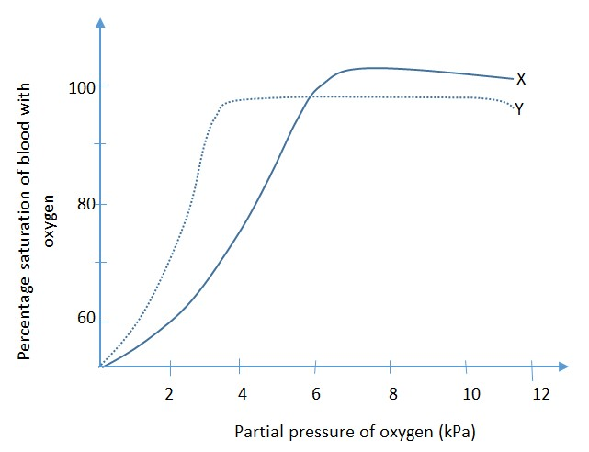

- From the figure, state three differences in the behavior of haemoglobin of the two animals.
(2marks)
X | y
Has a lower affinity for oxygen.  Has a lower rate of oxygen saturation  Releases oxygen slowly at lower oxygen partial pressures | Has a higher affinity for oxygen  Has a higher rate of oxygen saturation  Releases oxygen rapidly at lower oxygen partial pressures.
Other:
X | y
Becomes fully saturated only at oxygen partial pressures greater than 8kpa  Has a higher full saturation capacity (above  80%) | Becomes fully saturated only at oxygen partial pressures greater than 5kpa  Has a lower full saturation capacity (about  80%)
- (i) Outline the characteristics of the haemoglobin of animals y. (3marks)
  - Has a higher oxygen affinity
  - Has a high rate of oxygen uptake at lower oxygen partial pressures Others:
  - Becomes fully saturated at lower oxygen partial pressures ( ≤ 4kpa)
  - Has a high saturation capacity (over 80%)
(ii).From characteristics in (b) (i) suggest the nature of the habitat in which animal y lives
(01mark)
Animal y lives in a habitat with low oxygen partial pressures such as at high altitude or mud
(c ). Human haemoglobin has a higher affinity for carbon monoxide than oxygen. What is the effect of the fact? (03marks
In the haemoglobin molecule,, carbon monoxide readily replaces oxygen. It binds irreversibly with haemoglobin molecules and thus reduces oxygen carriage of the blood.
As a result, the body tissues are deprived of oxygen leading to tissue death.
- The figure below is a diagram showing part of mammalian circulation system

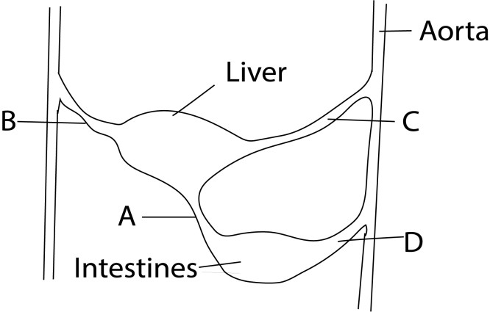
  - Name the blood vessels labeled A, B, C and D.(02 marks) A: Hepatic portal vein
B. Hepatic vein
C: Heopatic vein
D: mesenteric artery
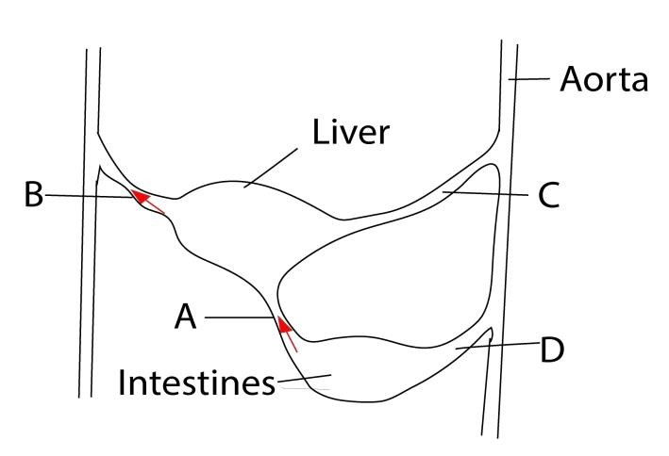
  - Using arrows, show on the diagram the direction of blood flow in blood vessels labeled A and B. (01mark)
.

  - State three differences in composition of blood flowing in A and B. (03marks) A contains high concentration of food nutrients than B
A contains less waste products than in B
A contains more oxygen than in B
  - Explain the changes in composition of glucose in A and B (02mark) Liver removes excess glucose from A and converts it to glycogen or fats
  - How is blood vessel A structurally adapted to perform its function?(02marks) Wide to reduce resistance to blood flow

- The table below shows the composition of blood of three adult individuals. One lives at high altitude, another is anaemic and the other has an infection. It also shows the average number of each blood component in an adult human. Study the information in the table and answer the questions that fallow.
Components of blood | Person A | Person B | Person C | Average number in adult human
Red blood cells per mm³ | 7,500,000 | 5,000,000 | 2,000,000 | 5,000,000
White blood cells per mm³ | 6,000 | 8,000 | 12,000 | 5,000 – 10,000
Blood platelets cells per  mm³ | 250,000 | 255,000 | 100,000 | 250,000
(a) Giving a reason, suggest the person
      - Who lives at high altitude (03marks) A has high number of red blood cells
      - Who is anemic (03marks)
C has low read blood cells than normal
(iii) Who has infection (03marks) C has big number of white blood cells
(b) Suggest a likely effect of observed number of blood platelets in person C (02marks) Formation of clot,

- (a) List the substances transported by the blood circulatory system (04marks)

(b) give the importance of transporting each of the substances named in (a) above. (11marks)

Substance Transported | Importance / Function
Oxygen (O₂) | Essential for cellular respiration (metabolism), the process that produces energy (ATP) for all bodily activities.
Carbon Dioxide  (CO₂) | A waste product of cellular respiration; it must be removed from tissues and transported to the lungs for exhalation to prevent toxic buildup and maintain blood pH  .
Nutrients | Absorbed from the digestive system (e.g., glucose, amino acids, fatty acids, vitamins, minerals); they provide the building blocks and energy required for cell growth, repair, and metabolism.
Hormones | Chemical messengers produced by endocrine glands; they coordinate and regulate diverse body functions, such as growth, metabolism, reproduction, and stress responses, by acting on target organs.
Waste Products | Metabolic wastes (e.g., urea, creatinine, excess water, salts) produced by cells are transported to the kidneys for excretion as urine, preventing toxic accumulation in the body.
Heat | Blood helps in thermoregulation (maintaining a stable body temperature) by transferring heat from actively respiring tissues to the skin's surface, where it can be dissipated.
Immune Cells and Antibodies | White blood cells (leukocytes) and antibodies (immunoglobulins) are transported to sites of infection or injury to provide defense against pathogens and facilitate healing.
Water | The main component of blood plasma; it acts as a solvent for all transported substances and is crucial for maintaining blood volume, pressure, and hydration of tissues.
- (a) What is an artery? (1mark)
An artery is a type of blood vessel that carries oxygenated blood away from the heart to the rest of the body's tissues and organs.
  - State three differences between artery and vein. (3marks)
Feature | Artery | Vein
Direction of Blood Flow | Carries blood away from the heart. | Carries blood toward the heart.
Oxygen Content | Generally carries oxygenated blood (except pulmonary artery). | Generally carries deoxygenated blood (except pulmonary vein).
Blood  Pressure | High pressure; blood flows in pulses. | Low pressure; blood flows smoothly and continuously.
Wall  Thickness | Walls are thicker, more muscular, and more elastic. | Walls are thinner, less muscular, and less elastic.
Valves | No valves (except semilunar valves at the heart's exit). | Have valves (especially in limbs) to prevent backflow.
Lumen Size | Has a smaller internal diameter (lumen). | Has a larger internal diameter (lumen).
  - State how arteries and veins are suited for their function
    - artery (03marks)
      - Thick muscles to withstand pressure
      - Elastic wall to withstand pressure surge
      - Narrow lumen to maintain high pressure
      - Smooth endothelium to reduce friction on blood
      - Located deep in the body for protection

    - veins (03marks)
      - Valves prevent blood from flowing backwards
      - Thin wall to reduce resistance blood flow
      - Large lumen to reduce resistance to blood flow

Revision question about defense against disease
- Which one of the following couple is likely to produce a fetus suffering from fatal erythroblastosis?
  - Rh⁺ mother and Rh⁻ father
  - Rh⁻ mother and Rh⁻ father
  - Rh⁺ mother and Rh⁺ father
  - Rh⁻ mother and Rh⁺ father D
* This happens when an Rh-negative mother carries an Rh-positive fetus, which can occur if the father is Rh-positive. The mother's immune system may create antibodies against the Rh-positive red blood cells of the fetus, which can cross the placenta and destroy the fetal red blood cells, leading to severe anemia. This is particularly a risk in a second or subsequent pregnancy
- When a fetus receives antibodies from the mother through the placenta, it acquires
  - Active immunity
  - Long-term immunity
  - Passive immunity
  - Artificial immunity C 3. Which one of the following is not the method by which antibodies attack antigen?
  - Engulfing
  - Agglutination C. Lysis
D. Absorption on surface A
4. Which one of the following are target cells for the HIV (AIDS virus)?
- Erythrocytes
- Thrombocytes
- Lymphocytes
- Phagocytes C
* Explanation
- HIV targets immune cells. Human Immunodeficiency Virus (HIV) attacks the body's immune system, specifically white blood cells.
- Lymphocytes are a type of white blood cell. The primary targets of HIV are a specific type of lymphocyte called CD4+ T helper cells.
- The virus uses CD4+ T cells to replicate. HIV binds to the CD4 molecule on the surface of these cells and uses them to multiply, ultimately destroying them and weakening the immune system.
- Which of the following statement about immunity is incorrect?
  - Heat killed bacteria become antibodies when injected into an animal.
  - Antibodies are special proteins
  - Antibodies are produced against specific antigen
  - Antigens can be molecules on foreign microbe A
- The biochemical property of blood essential for its protective function of the body is the A. ability to clot.
    - possession of antibodies.
    - presence of hemoglobin.
    - possession of white blood cells. B
- The figure below shows the immune response of a person’s blood after vaccinations are given on day one and 60days later.


20
40 60 80
100

Time in days

Relative number of
antibodies

  - What is the effect of giving immunization to an individual? (1Mark)
Immunization provides an individual with immunity (resistance) to a specific infectious disease
  - From the graph, state the type of immunity acquired by the individual, giving a reason. (2marks)
Active immunity because it was able to recognize and respond rapidly to reintroduced pathogen after 60 days .
  - Explain the shape of the graph (04marks)
Vaccination triggered an immune response without causing illness and the body produced memory cells to remember how to fight the real pathogen later
When the body was exposed to the real pathogen 60 days later, the memory cells and antibodies quickly mounted a defense, to prevent the illness.

  - Describe three ways in which antibodies combat antigens (3marks)
    - Neutralization: Antibodies bind directly to a pathogen or toxin, blocking it from interacting with host cells or neutralizing its harmful effects. For example, they can block viral proteins needed to enter a cell, rendering the virus unable to infect.
    - Opsonization: Antibodies act as "tags" or "handles" on the surface of pathogens. This coating, or opsonization, makes it easier for phagocytic cells like macrophages and neutrophils to recognize, bind to, and engulf the pathogen for destruction.
    - Complement Activation: When antibodies bind to a pathogen, they can trigger the complement system. This is a cascade of proteins that can lead to the lysis (bursting) of the microbial cell or further attract immune cells to the site of infection.
    - Agglutination: Antibodies link multiple pathogens together, forming large clumps that are easier for phagocytes to clear from the body.
    - Precipitation: Antibodies cause soluble antigens to clump together and fall out of solution, making them easier targets for phagocytosis.

